2021
Delaware School Board Election Playbook

- Why
- When
- How

This is the Year to Get Involved!
Deadline to Register:
March 5th, 430pm
Don’t Wait, Act Now!
Table of Contents

Letter of Introduction
3 - 4
Cheat Sheet
5 – 11
Finances
12 - 14
Resources
15 - 16
Complete Open Seat List
17 – 18
Equity Lens Analysis
19 - 40
Newcastle
41 - 68
Kent
69 - 99
Sussex
100 – 140
Appendix: Carney & Street at Redding
141 – 153

Dear Potential School Board Candidate,
Thank you for thinking about running for your local school board. Now do it!
This playbook is dedicated to Lillian Oliver and Grace Otley, two young women who ran for Red Clay School Board in 2020.
Did they win? No. But they ran great campaigns. They were up against incumbents, in their seats since 1999 and 2010. The incumbents prevailed.
Grace and Lillian inspired me with their courage, creativity, and ideas. 3,798 votes were cast in a July school board election in the middle of a pandemic.
I’d like to see school districts up and down Delaware have record voter turn-outs because more passionate people took the time to either actively support a candidate, or run as a candidate themselves.
I am an education advocate because systemic racism is embedded in our DE public school system, our State Constitution, our Delaware Codes, our Administration’s guidance. Top to bottom. Delaware is not fulfilling its duty of providing a general and efficient education for all children. The data shows Delaware’s Opportunity Gaps are substantial. They are also avoidable.
I believe this because of what I’ve seen and experienced firsthand. I saw a child’s human and civil rights violated because the resources were not there to enable success in literacy.
We failed that student, and Delaware’s system has been failing low-income Black and Brown students every year. Special Education students and English as a Second Language students are also under served.
We are fairly successful in teaching White, middle-class English speaking children how to proficiently read and do math in our Delaware public schools. Although, this could also improve. Let’s continue to improve while also redesigning our system to provide education for all children.
Redesign is a strong word; we have everything we know that works identified and ready to implement. Someone, i.e. Governor Carney, just needs to let us and lead us, and that is why I include Governor Carney in the guide.
Let’s support our legislators heavy lift for education in the General Assembly by getting involved at the ground level.
This playbook is intended to make it easier for you to get involved. Share it with anyone and everyone you think could help make education an urgent issue in the minds and hearts of our community members.

With Love,
Amy Solomon Gallagher
amsolomon28@outlook.com

Cheat Sheet
Newcastle School District Map
(302) 577-3464 [Press 0]
Carvel State Office Building
820 North French St Suite 400
Wilmington DE 19801

Call your Elections Office & File!
- No initial filing fee; you will need to make an appointment to go into the office and fill out the filing form, or print it out at home and have it notarized (easier to go in since they can be helpful);
  - Bring your driver’s license: they will check where you live, and you may want to have an alternate email, phone number, and mailing address if you do not want your personal info to be made public. Everything on your form gets put online, you have the opportunity to provide website details for your campaign
- They will provide a Map of the District, make a copy of the filing form and give it you, notify the District you have filed, and post it on Facebook. This is when you apply for the data file and voter registration info for your District. You can: receive it in the mail, via email, or pick it up at the office at a later date. It takes a week to get the data
- You may be able to get a copy of the Spreadsheet of who has run for that District and that Seat as they keep track. It’s an unusual request, best to find online, but you can always ask
- Registration is immediate despite waiting on your data, and you can start campaigning straight away
Link to School Board Packet
Link to CFRS
The Municipal Candidate Guideline which details which form to file also is included in the School Board Packet

Kent School District Map
(302) 739-4498 [Press 0]
100 Enterprise Pl Ste 5
Dover DE, 19904

Call your Elections Office & File!
- No initial filing fee; you will need to make an appointment to go into the office and fill out the filing form, or print it out at home and have it notarized (easier to go in since they can be helpful);
  - Bring your driver’s license: they will check where you live, and you may want to have an alternate email, phone number, and mailing address if you do not want your personal info to be made public. Everything on your form gets put online, you have the opportunity to provide website details for your campaign
- They will provide a Map of the District, make a copy of the filing form and give it you, notify the District you have filed after March 5th, and post it to social media immediately. This is when you apply for the data file and voter registration info for your District. You can: receive it in the mail, via email, or pick it up at the office at a later date. There is a 24 to 48 hour window to get data
- You may be able to get a copy of the Spreadsheet of who has run for that District and that Seat as they keep track. It’s an unusual request, best to find online, but you can always ask
- Registration is immediate despite waiting on your data, and you can start campaigning straight away
Link to School Board Packet
Link to CFRS
The Municipal Candidate Guideline which details which form to file also is included in the School Board Packet

Sussex
(302) 856-5367 [Press 0]
119 N. Race St
P.O Box 457
Georgetown, DE 19947

Call your Elections Office & File!
- No initial filing fee; you can go into the office without an appointment between 8 a.m. and 4:30 p.m. to fill out the filing form, or print it out at home and have it notarized (easier to go in since they can be helpful);
  - Bring your driver’s license: they will check where you live, and you may want to have an alternate email, phone number, and mailing address if you do not want your personal info to be made public. Everything on your form gets put online, you have the opportunity to provide website details for your campaign
- They will provide a Map of the District, make a copy of the filing form and give it you and notify the District you have filed after March 5th. This is when you apply for the data file and voter registration info for your District. You can: receive it in the mail, via email, or pick it up at the office at a later date. There’s a 24 to 48 hour window to get data, but you can normally get it in the same day.
- You may be able to get a copy of the Spreadsheet of who has run for that District and that Seat as they keep track. It’s an unusual request, best to find online, but you can always ask
- Registration is immediate despite waiting on your data, and you can start campaigning straight away
Link to School Board Packet
Link to CFRS
The Municipal Candidate Guideline which details which form to file also is included in the School Board Packet

Requirements
- 18 years old
- US Citizen and Delaware resident within the School District you are running for, and potentially a resident of the Nominating Area/Specific District area that applies to the 2021 open Seat up for election
- Title 14 claims there is no requirement on the amount of time you’ve been living at your house before filing
- You can’t be a paid employee of the District, subject to Rules and Regulations of the Board
- There will be a criminal history and background check in the process of attaining your seat on school board. If you have had experience with the legal system or incarceration, you can still call and apply.

Finances
You don’t have to register a Campaign Committee if spending under $2000. Keep all receipts!
- This is an honor system, and it doesn’t matter whose money you spend. If you try to bypass the system, for example sending out campaign literature in the post office which is expensive (and your local RD members will know this), someone could complain about you. The Elections Commissioner has to follow up, and the process becomes problematic. Stick to the rules and you will be just fine.
- Once you hit $2000, you have 7 days to file for a Committee. You will get a School Board packet from the Campaign Finance Team

If you do want to start a Campaign Committee:
- After you file as a School Board Candidate, you can contact this office:
  - The Campaign Finance Team:
Office of the State Election Commissioner
905 S. Governors Ave, Suite 170
Dover, DE 19904
Phone: (302) 739-4277
Fax: (302) 739-6794
Email: coe_campaignfinance@state.de.us

- Press 1 and Press 1 again to speak with an agent

- You need to get an ISN number in order to set up your Campaign Committee (you will get this on the phone), and then you go to this link to register your Committee. Print out forms and have them notarized. I go to my local UPS store for notary services (I think it was less than $20).

- Be prepared to sign your documents with your notary:
  - Bring a valid, government issued photo ID with you when you visit for notary services.
  - Be sure to bring all of the documents that need to be notarized with you.
  - Be sure the documents are complete and ready for signature. If you need legal advice, please consult an attorney. The notary public is prohibited from helping you to prepare, complete, or understand legal documents.
  - If short on time, you can scan notarized form and send them to your campaign finance team contact via email, but you do also have to physically send the form in to this address:
    - Office of the State Election Commissioner
905 S. Governors Ave, Suite 170
Dover, DE 19904

- Obtain an EIN number – you can do this online - EIN Individual Request - Online Application IRS - you will need this to get a Bank account and for Act Blue.
  - Start to get in touch with ACT Blue. It’s how you will collect and document donations, which, if you’re spending over $2000, you may want to do
    - Go to the website ActBlue and click on the button “Get Set Up” and fill out the info. You don’t have to have everything ready to make that initial online contact.
    - After you submit the online form, you will get emails and follow up correspondence.
    - This process takes a week or two to set up. Here is what they’ll say once you go online, register and they start emailing you individually:
      - “That's great to hear! Once you have your bank account set up, you'll want to complete the merchant account setup form (https://secure.actblue.com/merch-setup). This will ask for your bank account info, EIN and some other basic campaign information. If you want to email me once you submit that form, I can let our team know and try to get it expedited since it can take between 5-7 business days to get the account finalized.”

- You need to set up a Bank Account for your Campaign Committee – M&T Bank is very helpful, call your local branch and set up an appointment.

Resources
Online:
XQ- That’s A School Board Thing
-Demystifies the work of local school boards so you can get involved, run to serve, and serve for change. Thank you, Drew Serres!

Organizations to Connect With:
First State Educate
School Board Partners
-Thank you Laurisa Schutt!
Delaware PTA
-Thank you Yvonne Johnson!
Network Delaware
Delaware United

Additional:
- The Best and Worst Places to Grow Up: How Your Area Compares - The New York Times
  - This is a must use tool from Raj Chetty. Put in Sussex, New Castle, or Kent County in upper left hand box and Delaware will pop up. The information is startling
- Big Data to Solve Economic and Social Problems | Opportunity Insights
  - Free online course from Raj Chetty
- Education Trust
  - Education Trust Contact for Delaware is Marissa Alberty malberty@edtrust.org
- BPP Education Report
- Metropolitan Wilmington Urban League
- Wilmington Center for Education Equity and Policy
- Rodel Foundation of Delaware
- Redding Consortium for Educational Equity | (solutionsfordelawareschools.com)
- Delaware Department of Education
- Delaware CAN
- Delaware State Education Association
- Delaware State Board of Education

2021 Open Seats by County, District, and Current Board Member

Newcastle – no one filed, as of Jan 19th
- Appoquinimink – Richard Forsten (filing to run again, but not yet filed as of Jan 19th); Seat at Large
- Brandywine – Dr. Debbi Zarek, District F
- Christina – Monica Moriak, District B; Warren Howell, District F; Susan Mitchell, District G
- Colonial – Joseph T. Laws, District F; Richard Schiller, District C
- Red Clay – Dr. Faith Newton, District F
Kent – no one filed, as of Jan 19th
- Caesar Rodney –Mr. Mike Marasco, At large
- Capital – Dr. Chanda Jackson-Short, At Large
- Lake Forest – Mr Earle Dempsey, At Large
- Milford – Renate Wilson, Area C;
And A 1 yr currently vacant seat, Area D
- Smyrna – Kathryn O’Connell, At Large
Sussex – one filed as of Jan 19th, noted
*Since no seat is available in Indian River, All Seats up for Election in Sussex are At Large – 5 yr terms
- Cape Henlopen – Dr Janis Hanwell
- Delmar – Farrah D. Morelli; Shawn Brittingham
- Indian River – Not until 2023
- Laurel – Mr. Shane McCarty
- Seaford – Mrs. Kimberly Hopkins, has filed
- Woodbridge – Danielle Taylor

Analysis
Jan 20th, 2021, Equity Lens Analysis of DOE Report Card Data, Online at State Report Cards - Delaware Department of Education

I went to a lot of trouble to cut and paste race & ethnicity associated data from the online DOE Report Card for every Delaware School District with an Open Seat (and Indian River). I also pulled a chart from Delaware Data Online. And I tried to provide accurate links to the data throughout this guide.

Why did I want you to look at the race related data, specifically for Black, Hispanic/Latino, and White students?
I provided you specific DOE data to show you the story the DOE and Governor Carney would like you to be satisfied with. Some current School Board members throughout Delaware are proud of being slightly at or above the State averages. These State and District averages were designed in a way to present the facts not through an equity lens, but to satisfy a definition of “general” and “efficient.” Our data has been molded to align with the values in our State Constitution.

With the recent White House insurrection, I believe we have been reminded how important the stories we tell are, both to ourselves and the communities we live in.
Our beliefs that we gain from what we choose to take in or ignore do have an effect on our neighbors.
You may think what you are, or are not doing, as relates to Delaware public school education is nothing near as dramatic as what we witnessed in Washington, D.C.
I beg to differ.
Our collective action or inaction regarding DE public schools has allowed certain disparities to persist and entrench themselves.

The United Way of Delaware provides a statistic that a child who cannot read at grade level by the 4th grade is 14 times more likely to go to jail and has a 90% chance of living in poverty.
This has a visible and undeniable effect in our communities.
When you connect the dots and realize that the State of Delaware, despite constant advocate activity, has never gone too far out of its way to truly provide an equitable education for all Delaware children, you should be aware of the fallout from staying that course.
The Delaware State Constitution provides only for a “General” and “Efficient” education for Delaware students. Somehow, that means something different for White children than Black children still to this day, in 2021.
The same data tells a very different story when put through a different process. We are all more than just numbers on a page. Your personal experiences will resonate with constituents far more than figures.
I do want to show you what the DOE chooses not to highlight too loudly and ask that on your path to becoming a School Board Member, you inform yourself, educate yourself and fight for equitable outcomes for all of Delaware’s children.
I will walk you through a visualization exercise now, using data Tables 1 – 6, created from the DOE Report cards.

Table 1
This Table shows the total number of students in each of the School Districts up for election. I added up the percentage figures in the Meets & Exceeds categories from the ELA data (included in this guide) for Black students (B) and White students (W)
You can see that the % of (W) students in these two categories that represent proficiency and signifies being ready for the next ELA level, exceed the % of (B) students in every district.
I highlighted in yellow the difference in % between (B) and (W) students. The range in % difference is 15% - 44%, with an average of 27% points difference.

Delaware County | School District | Student Total | Meets & Exceeds ELA % (B) | Meets & Exceeds ELA % (W) | % Difference ELA
New Castle | Appoquinimink | 11,737 | 51 | 72 | 21
New Castle | Brandywine | 10,548 | 34 | 70 | 36
New Castle | Christina | 14,003 | 28 | 54 | 26
New Castle | Colonial | 9,921 | 34 | 49 | 15
New Castle | Red Clay | 17,069 | 26 | 70 | 44
Kent | Caesar Rodney | 8,183 | 45 | 72 | 27
Kent | Capital | 6,605 | 35 | 60 | 25
Kent | Lake Forest | 3,721 | 38 | 66 | 28
Kent | Milford | 4,301 | 35 | 63 | 28
Kent | Smyrna | 5,882 | 44 | 62 | 18
Sussex | Cape Henlopen | 3,850 | 35 | 76 | 41
Sussex | Delmar | 1,405 | 32 | 57 | 25
Sussex | Indian River | 10,942 | 41 | 70 | 29
Sussex | Laurel | 2,645 | 36 | 56 | 20
Sussex | Seaford | 3,516 | 43 | 61 | 18
Sussex | Woodbridge | 2,594 | 25 | 49 | 24
Table 1

Table 2
This Table shows the total number of students in each of the School Districts up for election. I added up the percentage figures in the Meets & Exceeds categories from the Maths data (included in this guide) for Black students (B) and White students (W)
You can see that the % of (W) students in these two categories that represent proficiency and signifies being ready for the next Maths level, exceed the % of (B) students in every district.
I highlighted in orange the difference in % between (B) and (W) students. The range in % difference is 15% - 45%, with an average of 28% points difference.
The School District of Delmar in Sussex had the data for the (W) students locked, so I had to guess the range from what I could see. I could not add Delmar in the Maths tally.

Table 2
Delaware County | School District | Student Total | Meets & Exceeds Maths % (B) | Meets & Exceeds Maths % (W) | % Difference Maths - Meets & Exceeds
New Castle | Appoquinimink | 11,737 | 31 | 58 | 27
New Castle | Brandywine | 10,548 | 20 | 58 | 38
New Castle | Christina | 14,003 | 23 | 51 | 28
New Castle | Colonial | 9,921 | 20 | 35 | 15
New Castle | Red Clay | 17,069 | 11 | 56 | 45
Kent | Caesar Rodney | 8,183 | 29 | 57 | 28
Kent | Capital | 6,605 | 23 | 45 | 22
Kent | Lake Forest | 3,721 | 33 | 57 | 24
Kent | Milford | 4,301 | 25 | 55 | 30
Kent | Smyrna | 5,882 | 33 | 55 | 22
Sussex | Cape Henlopen | 3,850 | 24 | 66 | 42
Sussex | Delmar | 1,405 | 12 | N/A 47 - 66 range | N/A 35-54 range
Sussex | Indian River | 10,942 | 33 | 63 | 30
Sussex | Laurel | 2,645 | 23 | 47 | 24
Sussex | Seaford | 3,516 | 34 | 53 | 19
Sussex | Woodbridge | 2,594 | 19 | 41 | 22

Table 3
This Table shows the total number of students in each of the School Districts up for election. I listed the percentage figure in the Well Below category from the ELA & Maths data (included in this guide) for Black students (B) and White students (W)
You can see that the % of (B) students in the Well Below category for both ELA and Maths, exceed the % of (W) students in every district.
I highlighted in yellow the difference in % between (B) and (W) students for ELA data. The range in % difference is 12% - 35%, with an average of 21% points difference.
I highlighted in orange the difference in % between (B) and (W) students for Maths data. The range in % difference is 16% - 40%, with an average of 23.5% points difference.

Table 3
Delaware County | School District | Student Total | Well Below ELA % (B) | Well Below ELA % (W) | % Difference ELA  Well Below | Well Below Maths % (B) | Well Below Maths % (W) | % Difference Maths Well Below
New Castle | Appoquinimink | 11,737 | 25 | 11 | 14 | 33 | 15 | 18
New Castle | Brandywine | 10,548 | 41 | 11 | 30 | 49 | 15 | 34
New Castle | Christina | 14,003 | 48 | 23 | 25 | 51 | 24 | 27
New Castle | Colonial | 9,921 | 39 | 27 | 12 | 49 | 33 | 16
New Castle | Red Clay | 17,069 | 48 | 13 | 35 | 58 | 18 | 40
Kent | Caesar Rodney | 8,183 | 29 | 11 | 18 | 39 | 15 | 24
Kent | Capital | 6,605 | 37 | 21 | 16 | 44 | 23 | 21
Kent | Lake Forest | 3,721 | 32 | 14 | 18 | 37 | 17 | 20
Kent | Milford | 4,301 | 35 | 16 | 19 | 38 | 18 | 20
Kent | Smyrna | 5,882 | 28 | 16 | 12 | 32 | 16 | 16
Sussex | Cape Henlopen | 3,850 | 38 | 9 | 29 | 45 | 12 | 33
Sussex | Delmar | 1,405 | 47 | 18 | 29 | 45 | N/A 28-45 range | N/A
Sussex | Indian River | 10,942 | 30 | 11 | 19 | 33 | 13 | 20
Sussex | Laurel | 2,645 | 37 | 20 | 17 | 46 | 24 | 22
Sussex | Seaford | 3,516 | 32 | 17 | 15 | 41 | 19 | 22
Sussex | Woodbridge | 2,594 | 51 | 25 | 26 | 51 | 31 | 20

Table 4
I went to the DOE Report Card’s demographic info and recorded the % difference in Overall Student Population between (B) and (W) students and signified the (+) amount with an ↑, noting whether the positive % was higher for (B) or (W) students.
I took the % total for (B) and (W) students from the same demographic data and translated that into the specific number of students that % represents for each School District. I based this on the total student populations pulled from the DOE Report Card data, which I also listed in Tables 1 – 3.
From the specific student total for (B) and (W) students, I established a rough ratio of (B):(W) students for each district, highlighted in purple. If a figure had a rounding of .3 or higher, I noted this decimal place in the ratio. Otherwise, I rounded up or down to the nearest whole number.
I then used the Table 1 data in the % Meets & Exceeds ELA category for (B) and (W) students to translate that % into the number of (B) and (W) students in the District that Meet & Exceed ELA proficiency standards.
I again established a rough ratio of (B):(W) students that Meet & Exceed ELA proficiency standards, highlighted in yellow.
By showing you the physical number of students in each District and the ratio of (B):(W) students in the district – I want you to begin to visualize the diversity present in your specific District.
Once we factor in a category – like Meets & Exceeds ELA – you can visualize how the diversity shifts for academic success.
In order to represent an equitable outcome for the Meets & Exceeds ELA data, you would want the ratio to equal and reflect the same student population ratio.
The more the Meet & Exceeds ELA ratio deviates in relation to the student population ratio – the more inequitable.
By comparing the purple and yellow columns in Table 4, you can gauge the reach of Opportunity Gaps in your District and how gaps compare to other Districts.
Please do not normalize Opportunity Gaps or say “my District isn’t the worst – we’re okay.” Please notice instead the persistent and systematic way Opportunity Gaps have established a pattern in Delaware and also be aware there are identified solutions that can change this pattern. Our School Boards, Governor and Legislative members need to recognize that we want to implement solutions urgently – make your voice heard.

Please realize, Table 1-3 establish a persistent Opportunity Gap between (B) & (W) students.
Table 4 works to translate the 28% Opportunity Gap in Meets & Exceeds ELA data into a measurement you can Visualize.
The jump that takes place from a 1 (B) to 6 (W) students’ ratio in the student population of Cape Henlopen to a 1 (B) to 15 (W) students that Meet & Exceed in ELA proficiency levels represents the largest inequity included on the table.
However, the inequity jump in Red Clay from 1:2 to 1: 5.5, although presented here as smaller compared to Cape Henlopen, effects 5 to 6 times as many (B) students as Red Clay has a much larger overall and (B) student population.

So, taking the difference in equity into account - these 3 (B) Red Clay students would then be missing from our theoretical class of 24 students who Meet & Exceed ELA requirements:
When this happens in ten theoretical Red Clay classrooms spread throughout the District – suddenly these 30 kids are blocked out of meeting ELA proficiency standards due to lack of appropriate resources being dedicated to their success at the necessary time:
(I count 12 in the group photo, plus 6 more = 30)
Table 4
Delaware County | School District | % Difference in Overall Student Population between (B) & (W) | (B) Student Total | (W) Student Total | Approx Ratio (B):(W) Students | Meets & Exceeds ELA (B) | Meets & Exceeds ELA (W) | Approx. Ratio of (B):(W) Students for Meets & Exceeds ELA
New Castle | Appoquinimink | ↑ 25.81 (W) | 3,189 | 6,218 | 1 to 2 | 1,626 | 4,477 | 1 to 3
New Castle | Brandywine | ↑5.49 (w) | 4,008 | 4,587 | 1 to 1 | 1,363 | 3,211 | 1 to 2.4
New Castle | Christina | ↑11.94 (B) | 5,479 | 3,807 | 1.4 to 1 | 1,534 | 2,056 | 1 to 1.3
New Castle | Colonial | ↑17.9 (B) | 4,445 | 2,670 | 1.7 to 1 | 1,511 | 1,308 | 1 to 1
New Castle | Red Clay | ↑ 21.35 (W) | 3,492 | 7,136 | 1 to 2 | 908 | 4,995 | 1 to 5.5
Kent | Caesar Rodney | ↑ 28.43 (W) | 2,109 | 4,435 | 1 to 2 | 949 | 3,193 | 1 to 3.4
Kent | Capital | ↑ 26.18 (B) | 3,440 | 1,710 | 2 to 1 | 1,204 | 1,026 | 1 to 1
Kent | Lake Forest | ↑39.66 (W) | 811 | 2,287 | 1 to 3 | 308 | 1,509 | 1 to 5
Kent | Milford | ↑23.51 (W) | 1,071 | 2,082 | 1 to 2 | 375 | 1,312 | 1 to 3.5
Kent | Smyrna | ↑28.34 (W) | 1,724 | 3,391 | 1 to 2 | 759 | 2,102 | 1 to 3
Sussex | Cape Henlopen | ↑ 55.47 (W) | 669 | 3,919 | 1 to 6 | 201 | 2,978 | 1 to 15
Sussex | Delmar | ↑49.9 (W) | 208 | 909 | 1 to 4.4 | 67 | 518 | 1 to 7.7
Sussex | Indian River | ↑ 35.45 (W) | 1,209 | 5,088 | 1 to 4 | 496 | 3,562 | 1 to 7
Sussex | Laurel | ↑ 22.15 (W) | 695 | 1,281 | 1 to 2 | 250 | 717 | 1 to 3
Sussex | Seaford | ↑2.67 (B) | 1,264 | 1,170 | 1 to 1 | 543 | 714 | 1 to 1.3
Sussex | Woodbridge | ↑22.55 (W) | 554 | 1,139 | 1 to 2 | 139 | 558 | 1 to 4
Table 5
Please reference Table 4’s methodology. I used the same process for Table 5, but I switched the categories to Meets & Exceeds Maths and highlighted that ratio in orange.
Again - in order to represent an equitable outcome for the Meets & Exceeds Maths data, you would want the ratio to equal and reflect the same student population ratio.
The more the Meet & Exceeds Maths ratio deviates in relation to the student population ratio – the more inequitable.
By comparing the purple and orange columns in Table 5, you can gauge the reach of Opportunity Gaps in your District and how gaps compare to other Districts.
If we stick to the Cape Henlopen and Red Clay examples, the jump that takes place from a 1 (B) to 6 (W) students’ ratio in the student population of Cape Henlopen to a 1 (B) to 16 (W) students that Meet & Exceed in Maths proficiency levels still represents the largest inequity included on the table.
However, the inequity jump in Red Clay from 1:2 to 1:10.4, although still smaller compared to Cape Henlopen, has almost doubled and still effects 5 to 6 times as many (B) students.

When this happens, 60 Red Clay (B) Maths students are now not ready for the next level:

At first glance, Christina may look equitable because the numbers are similar and there is a lower gap. However, the 1.4 (B) to 1 (W) student ratio in Christina means you should find more (B) students that Meet & Exceed ELA standards. What happens, is the ratio flips and you find 1 (B) student for every 1.5 (W) students – so more (W) children meet proficiency levels, even though there are less (W) students than (B) students in the total student population.
Colonial looks to be one of the most equitable Districts. On tables 1-3, it consistently represents the bottom end of the range, ie the least % points difference between Black and White students. On Table 5, its ratio comparison is the best, (i.e., the ratios are the closest together).
But when you look at how Colonial students are testing - where the % scores rank – they are not only far below State averages, but Colonial ranks 11th out of 16 Districts for (B) students in Meets & Exceeds ELA and 16th out of 16 in the same category for (W) students. In Meets & Exceeds Maths, ranks 12th out of 15 Districts for (B) students and 15th out of 15 for (W) students.
Even though the % difference of 15% between (B) and (W) students Meets and Exceeds Maths is the lowest on the table, the 35% total Meets & Exceeds Maths for (W) students is the worst performance on the table. And the 20% total Meets & Exceeds Maths for (B) students is near the bottom for (B) students on the table – compare that to the Delaware State average of 42.1% that is Supposed to represent these kids.
You can see that once you compare the tables and analyze each Districts situation – they all have different outcomes but one similar story – that Black students are consistently experiencing Opportunity Gaps throughout the entire State of Delaware.
When you read Governor Carney’s statement in the Appendix section – please don’t buy that only Wilmington city schools need urgent help. They indeed do – I did not go into the re-segregation of DE schools and the abysmal testing figures found in Wilmington city schools – where the % differences in Red Clay individual schools among (B) and (W) students can be as high as 70%!!
Yet, more than Wilmington needs to be addressed. Carney frames it this way because he refuses to look at how the entire system needs urgent action based on widespread Opportunity Gaps found throughout Delaware. He mentions he has limits and that Councilman Jea Street and education reform advocates pushed him:
At the end of the day, they pushed us, and I basically said, “Look, I can only do so much.”
This is false. Carney holds the educational power lever in DE. Carney sets his own limits, which I believed are enforced by systemically racist viewpoints embedded in Delaware’s daily operations. Governor Carney’s attitude of, I am doing enough, is the single biggest obstacle for sufficient support of education in Delaware. This needs to change. Not that we oust Carney, but we must convince that viable, identified solutions are not negotiable or there will be political consequences in the form of electing officials outside the established Delaware Democrats norm. In a Democratic system, we can reward inaction with leaving office.
I would like school boards and education advocates to be able to work with Carney, not against him. That’s entirely on Carney.

Table 5
Delaware County | School District | % Difference in Overall Student Population between (B) & (W) | (B) Student Total | (W) Student Total | Approx.Ratio (B):(W) Students | Meets & Exceeds Maths (B) | Meets & Exceeds Maths (W) | Approx. Ratio of (B):(W) Students for Meets & Exceeds Maths
New Castle | Appoquinimink | ↑ 25.81 (W) | 3,189 | 6,218 | 1 to 2 | 989 | 3,606 | 1 to 3.6
New Castle | Brandywine | ↑5.49 (w) | 4,008 | 4,587 | 1 to 1 | 802 | 2,660 | 1 to 2.4
New Castle | Christina | ↑11.94 (B) | 5,479 | 3,807 | 1.4 to 1 | 1,260 | 1,942 | 1 to 1.5
New Castle | Colonial | ↑17.9 (B) | 4,445 | 2,670 | 1.7 to 1 | 889 | 935 | 1 to 1
New Castle | Red Clay | ↑ 21.35 (W) | 3,492 | 7,136 | 1 to 2 | 384 | 3,996 | 1 to 10.4
Kent | Caesar Rodney | ↑ 28.43 (W) | 2,109 | 4,435 | 1 to 2 | 612 | 2,528 | 1 to 4
Kent | Capital | ↑ 26.18 (B) | 3,440 | 1,710 | 2 to 1 | 791 | 770 | 1 to 1
Kent | Lake Forest | ↑39.66 (W) | 811 | 2,287 | 1 to 3 | 268 | 1,304 | 1 to 5
Kent | Milford | ↑23.51 (W) | 1,071 | 2,082 | 1 to 2 | 268 | 1,145 | 1 to 4.3
Kent | Smyrna | ↑28.34 (W) | 1,724 | 3,391 | 1 to 2 | 569 | 1,865 | 1 to 3.3
Sussex | Cape Henlopen | ↑ 55.47 (W) | 669 | 3,919 | 1 to 6 | 161 | 2,587 | 1 to 16
Sussex | Delmar | ↑49.9 | 208 | 909 | 1 to 4.4 | 25 | N/A | N/A
Sussex | Indian River | ↑ 35.45 (W) | 1,209 | 5,088 | 1 to 4 | 399 | 3,205 | 1 to 8
Sussex | Laurel | ↑ 22.15 (W) | 695 | 1,281 | 1 to 2 | 160 | 602 | 1 to 4
Sussex | Seaford | ↑2.67 (B) | 1,264 | 1,170 | 1 to 1 | 430 | 620 | 1 to 1.4
Sussex | Woodbridge | ↑22.55 (W) | 554 | 1,139 | 1 to 2 | 105 | 467 | 1 to 4.4
Table 6
If you’re still with me on Table 6, that is wonderful. Still the same methodology as Table 4 & 5, but now we’ve switched to examining the Well Below ratios for ELA and Maths. The columns are jam packed together, so I hope you can decipher the abbreviations for each column based on the previous tables.

By now, you should be practiced at looking at the pattern. What do you see?
I see in Brandywine, we have Black and White student populations in the 4,000 students range; with a slight 5% lean towards White students; yet the number of Black students that are Well Below ELA and Maths proficiency is 3 times as many; this translates into approx. 1000 Black students in each category that bear the cost of embedded inequities throughout their education.

School District | % Diff. in Overall Student Pop. between (B) & (W) | (B) Stud. Total | (W) Stud. Total | App. Ratio (B):(W) Stud. | Well Below ELA (B) | Well Below ELA (W) | App. Ratio of (B):(W) Stud. for Well Below ELA | Well Below Math (B) | Well Below Math(W) | App. Ratio of (B):(W) Stud. for Well Below Maths
App. | ↑ 25.81 (W) | 3,189 | 6,218 | 1 to 2 | 797 | 684 | 1 to 1 | 1,052 | 933 | 1 to 1
Brand | ↑5.49 (w) | 4,008 | 4,587 | 1 to 1 | 1,643 | 505 | 3.3 to 1 | 1,964 | 688 | 3 to 1
Christ. | ↑11.94 (B) | 5,479 | 3,807 | 1.4 to 1 | 2,630 | 876 | 3 to 1 | 2,794 | 91 | 30 to 1
Colon. | ↑17.9 (B) | 4,445 | 2,670 | 1.7 to 1 | 1,734 | 721 | 2.4 to 1 | 2,178 | 881 | 2.5 to 1
Red C. | ↑ 21.35 (W) | 3,492 | 7,136 | 1 to 2 | 1,676 | 928 | 1.8 to 1 | 2,025 | 1284 | 1.6 to 1
Caesar R. | ↑ 28.43 (W) | 2,109 | 4,435 | 1 to 2 | 611 | 444 | 1.4 to 1 | 822 | 665 | 1 to 1
Capital | ↑ 26.18 (B) | 3,440 | 1,710 | 2 to 1 | 1,273 | 359 | 3.5 to 1 | 1,514 | 393 | 4 to 1
Lake F. | ↑39.66 (W) | 811 | 2,287 | 1 to 3 | 260 | 320 | 1 to 1 | 300 | 389 | 1 to 1.3
Milford | ↑23.51 (W) | 1,071 | 2,082 | 1 to 2 | 375 | 333 | 1 to 1 | 407 | 375 | 1 to 4.3
Smyrna | ↑28.34 (W) | 1,724 | 3,391 | 1 to 2 | 483 | 543 | 1 to 1 | 552 | 543 | 1 to 1
Cape H. | ↑ 55.47 (W) | 669 | 3,919 | 1 to 6 | 254 | 353 | 1 to 1.4 | 301 | 470 | 1 to 1.6
Delmar | ↑49.9 | 208 | 909 | 1 to 4.4 | 98 | 164 | 1 to 1.7 | 94 | N/A | N/A
Indian R. | ↑ 35.45 (W) | 1,209 | 5,088 | 1 to 4 | 363 | 560 | 1 to 1.5 | 399 | 661 | 1 to 1.7
Laurel | ↑ 22.15 (W) | 695 | 1,281 | 1 to 2 | 257 | 256 | 1 to 1 | 320 | 307 | 1 to 1
Seaf. | ↑2.67 (B) | 1,264 | 1,170 | 1 to 1 | 404 | 199 | 2 to 1 | 518 | 221 | 2.3 to 1
Wood. | ↑22.55 (W) | 554 | 1,139 | 1 to 2 | 283 | 285 | 1 to 1 | 283 | 353 | 1 to 1.3
Table 6

This data is a superficial look into educational equity across Delaware.
In July 2020, I directly requested a Red Clay equity study from the DOE, and received this reply from Dr. Adrian Peoples, (who was very kind to pursue this on my behalf, receive an official answer and put it to paper):

“Generally, DDOE cannot undertake individual research projects.

We strongly believe that singling out one school district to evaluate their effectiveness in providing education to its students runs counter to the DDOE’s goal of being a support organization.

We believe a better approach would be to work directly with Red Clay's Superintendent, Equity Officer, and Data Forum representative to build on the data you cultivated in using the Open Data Portal to answer the vital questions concerning the children being served in Red Clay.

They have access to the same data and a vested interest in the outcome as they more directly serve the students of Red Clay and can add more context, nuance, and experience to the research.

I understand based on our phone conversation that this may not be the desired response, but we feel that working directly with Red Clay district leadership is the best way to achieve your goals.”

I also asked Dr. People’s for a definition of systemic racism, as it is something we must address. To address something, we need to name it. Here is my question and Dr People’s response,
"Could you please send me the DOE's definition of systemic racism and recommendations for courses of action when it has been identified?"

“This is a judicial and legislative question regarding an organic and ever changing challenge to the ideal of equality. Some Delaware citizens may define systematic racism as a set of related laws, regulations, policies, practices, and norms that establish, perpetuate, or exacerbate disadvantages to a group of people based on their race and/or ethnicity.

As for recommended courses of action, eradicating systemic racism requires commitment and cooperation at both the state and local level of parents, educators, administrators, legislators and concerned citizens. It is why the Department strives to work with Red Clay and the other local school districts and charter schools as they implement progressive ideas and support them in areas where a broader, state-wide approach is beneficial.

As you continue to work with Red Clay on the notion of an equity study and next steps to bring more equality to the children being served within the district, I am happy to keep the lines of communication open.”

Let’s Keep the Lines Open after you win a School Board seat & work to urgently address educational inequities in Delaware.

New Castle School Districts
1. Appoquinimink – Seat up for Richard Forsten
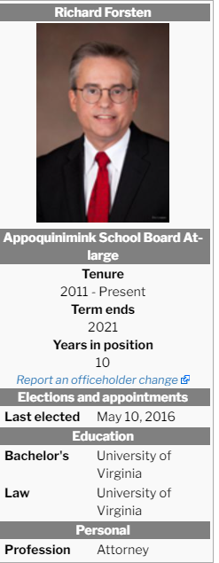
2011 – 2021 Richard Forsten, Esq – Term expires June 30, 2021
- Ran unopposed in 2016, election canceled due to lack of opponent; Republican delegate to 2016 RNC – one of 16 delegates bound to state party rules to support Trump
Richard Forsten | Exceptional Delaware (wordpress.com)
Forsten Named to Delaware Today's Top Lawyers 2019 List | Saul Ewing Arnstein & Lehr LLP
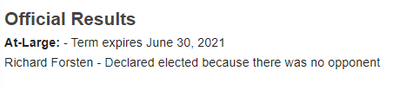

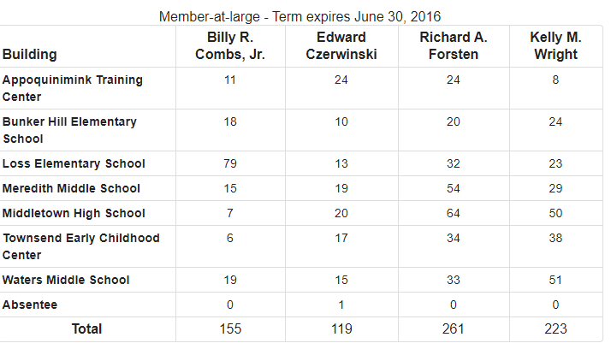
Above is 2011 Election result, Richard Forsten won by 38 votes in an election with 758 total votes – in a district that now has 11,737 students
Problem – Lack of Diversity
- Board looks to be 80% white in a district with over 5400 non-white students;
- District with 11,737 students
- 27.17% Black students, 8.2% Hispanic students, 4.07% Multi-Racial students, and 7.16% Asian American students; 10.69% of students are low income in this district; 15.81% students with disabilities; 3.46% ELA
Problem – Opportunity Gaps identifiable in data by race/ethnicity, ELA, income level and students with disabilities
- DOE Report Card Appoquinimink – This presents a 65.04% ELA and 50.53% Math proficiency;
- Yet if you look at Delaware Open Data Online –
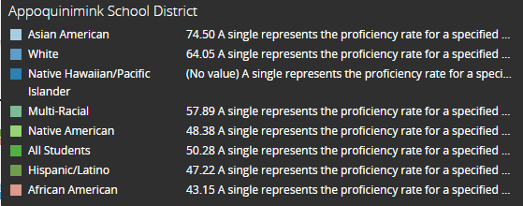
- Above is Average % Proficient by Race/Ethnicity
ELA Proficiency by Race/Ethnicity
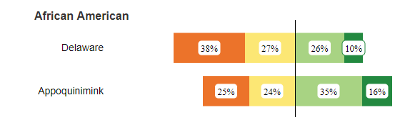
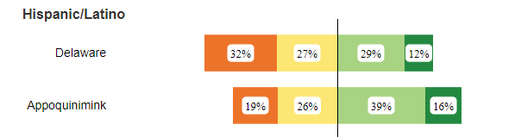
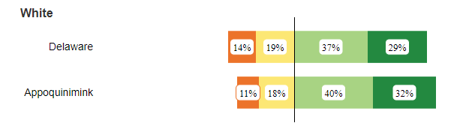

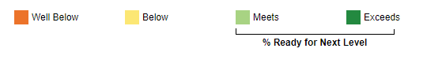
ELA Proficiency – Other Characteristics
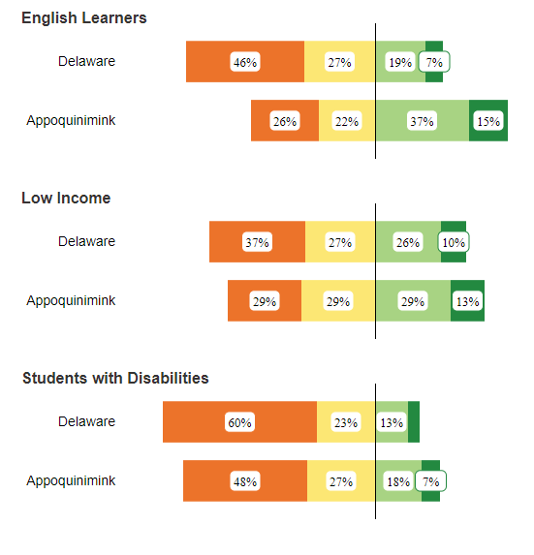
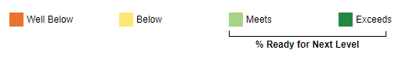
Math Proficiency by Race/Ethnicity
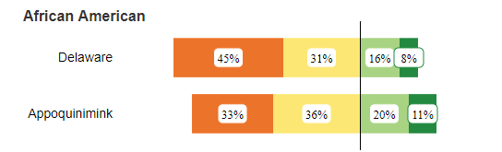

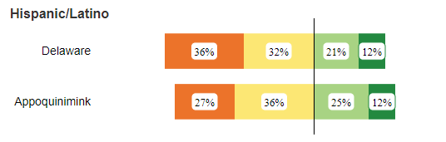

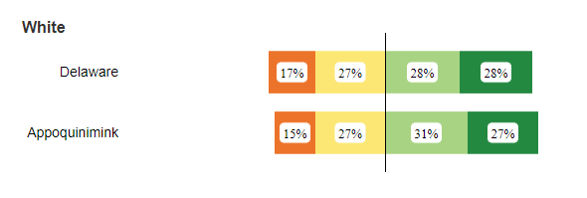

Math Proficiency by Other Characteristics

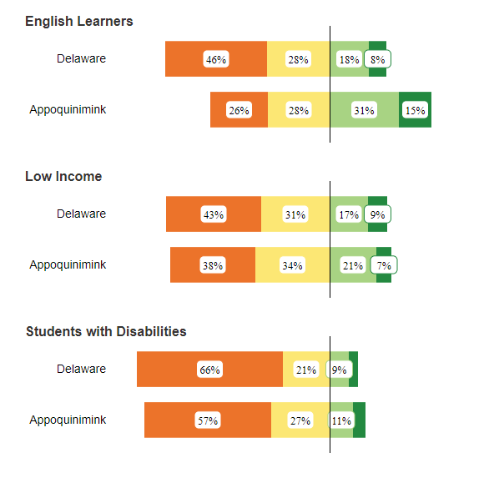

2. Brandywine – Seat up for Dr. Debbi Zarek, District F
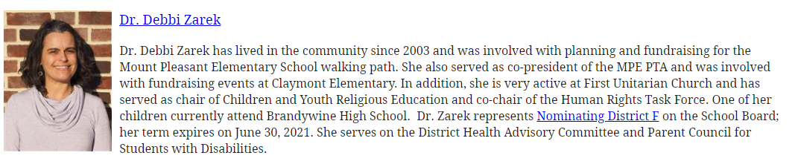Problem – Low Board Diversity
- District with 10,548 students
- 38% Black students, 7.52% Hispanic students, 3.33% Multi-Racial students, and 6.99% Asian American students; 26.66% of students are low income in this district; 17.25% students with disabilities; 5.06% ELA
- Problem – Opportunity Gaps identifiable in data by race/ethnicity, ELA, income level and students with disabilities
DOE Report Card Brandywine – This presents a 53.42% ELA and 41.51% Math proficiency;
Yet if you look at Delaware Open Data Online –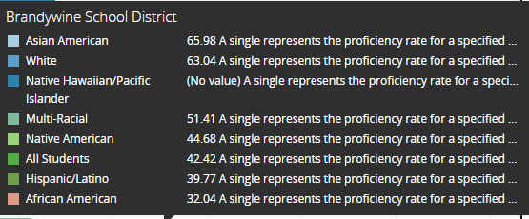
Above is Average % Proficient by Race/Ethnicity
ELA Proficiency by Race/Ethnicity
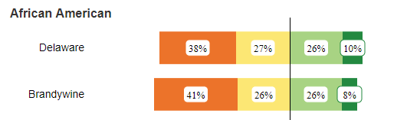
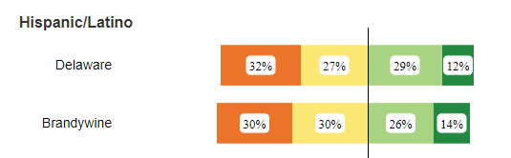
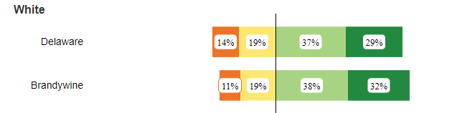

ELA Proficiency – Other Characteristics
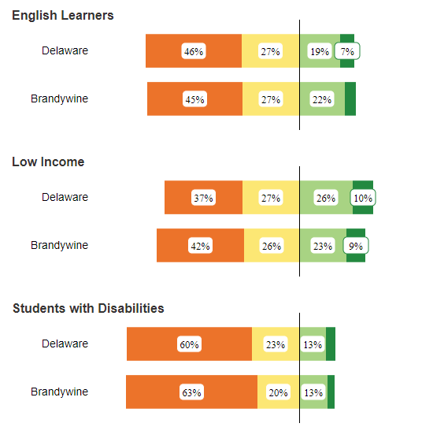

Math Proficiency by Race/Ethnicity
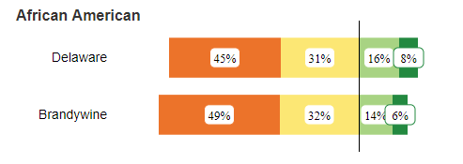
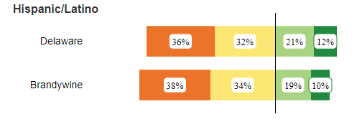
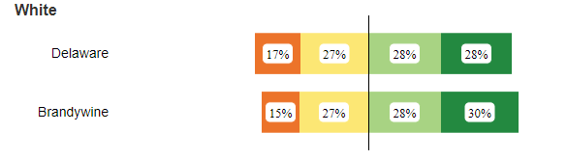
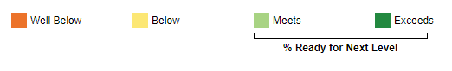

Math Proficiency by Other Characteristics
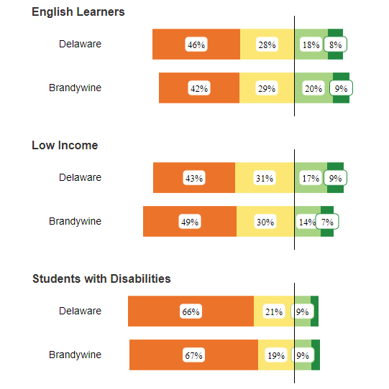

3. Christina – Seat up for Monica Moriak (District B), Warren Howell (District F), and Susan Mitchell (District G)
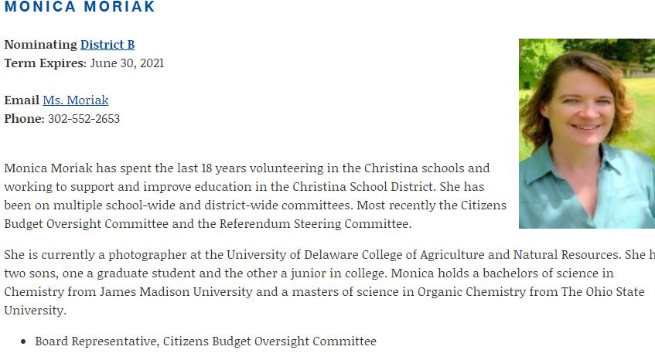
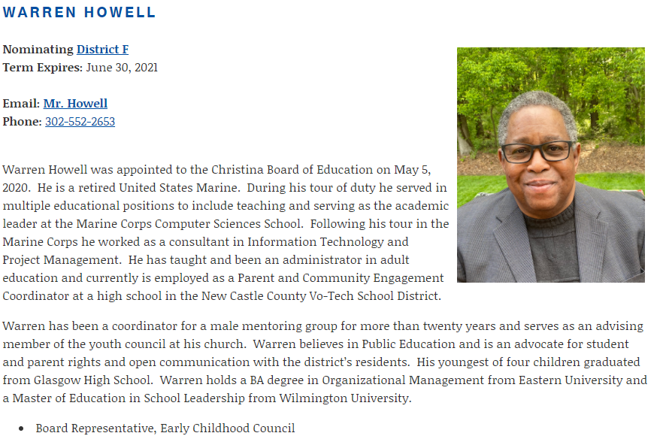
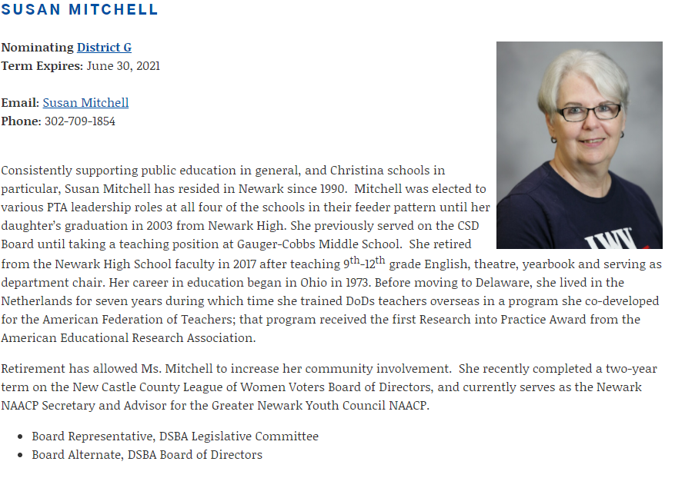
Problem – So many specific issues – One of the hardest hit Districts in terms of Equity
- District with 14,003 students
- 39.13% Black students, 21.85% Hispanic students, 5.18% Multi-Racial students, and 6.26% Asian American students; 36.61% of students are low income in this district; 22.84% students with disabilities; 12.19% ELA
Problem – Opportunity Gaps identifiable in data by race/ethnicity, ELA, income level and students with disabilities
DOE Report Card Christina – This presents a 39.23% ELA and 34.97% Math proficiency;

Yet if you look at Delaware Open Data Online
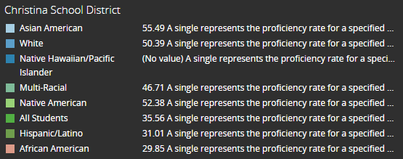
Above is Average % Proficient by Race/Ethnicity
ELA Proficiency by Race/Ethnicity
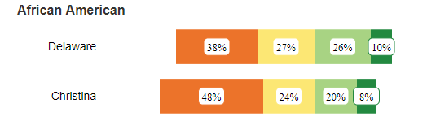
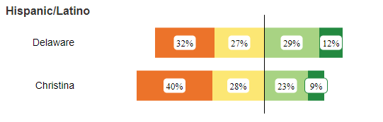
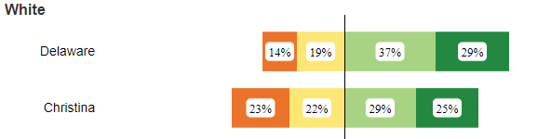
ELA Proficiency – Other Characteristics
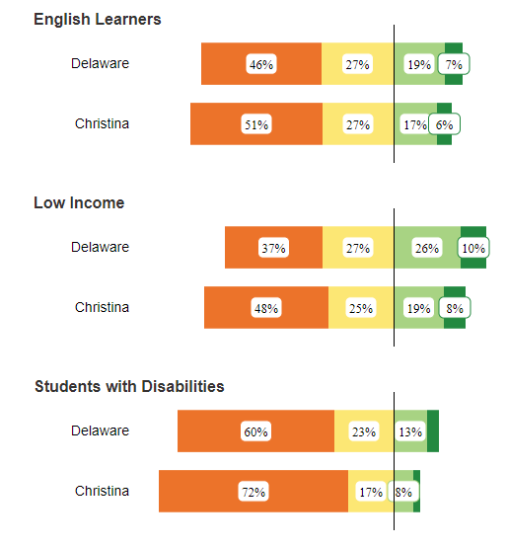

Math Proficiency by Race/Ethnicity
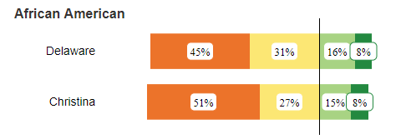
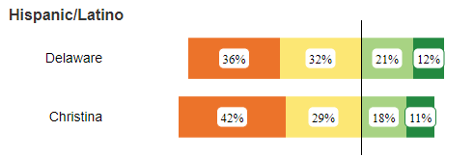
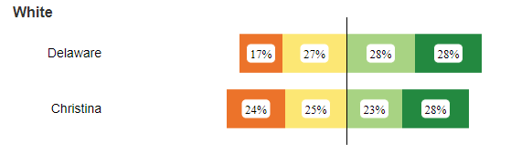

Math Proficiency by Other Characteristics
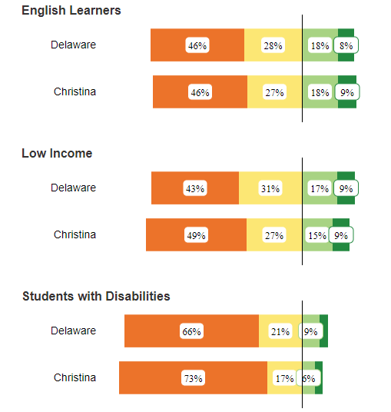

4. Colonial – Seat up for Joseph T. Laws, District F; Richard Schiller, District C -District C term expires June 30th, 2023. Fills balance of unexpired original term.
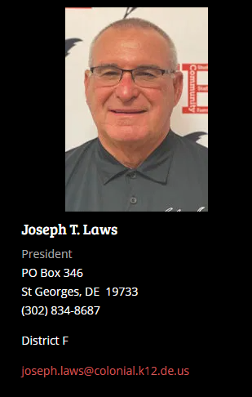
Problem – Low Board Diversity
- District with 9,921 students
- 44.81% Black students, 21.43% Hispanic students, 3.72% Multi-Racial students, and 2.68% Asian American students; 33.89% of students are low income in this district; 19.99% students with disabilities; 11.94% ELA
Problem – Opportunity Gaps identifiable in data by race/ethnicity, ELA, income level and students with disabilities
DOE Report Card Colonial – This presents a 39.61% ELA and 25.4% Math proficiency;

Yet if you look at Delaware Open Data Online
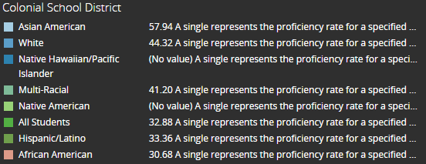
Above is Average % Proficient by Race/Ethnicity
ELA Proficiency by Race/Ethnicity
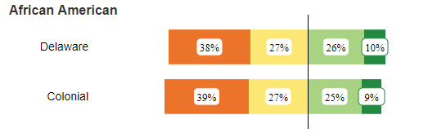
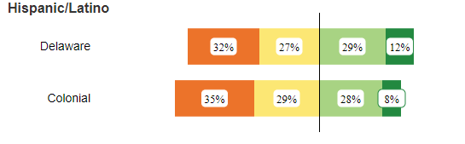
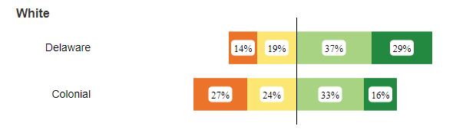

ELA Proficiency – Other Characteristics
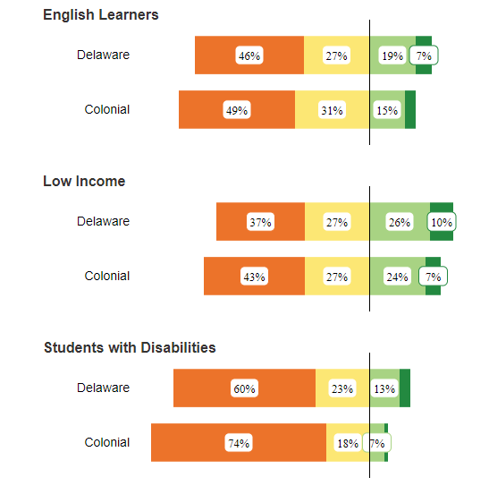

Math Proficiency by Race/Ethnicity
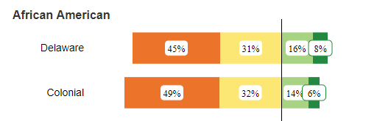
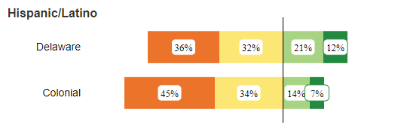
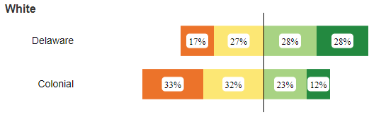

Math Proficiency by Other Characteristics
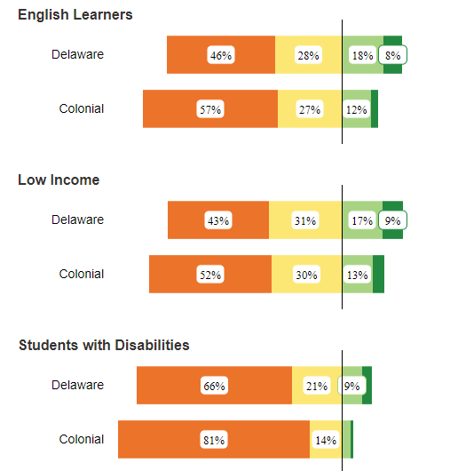
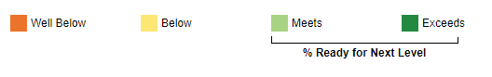

5. Red Clay– Seat up for Faith R. Newton, District F
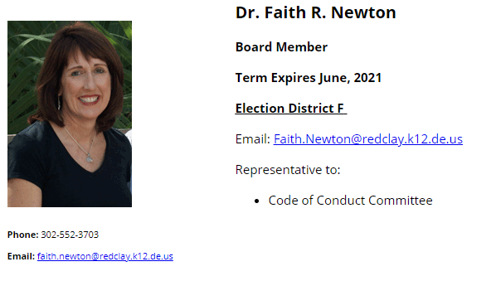
Problem – Long Term members (Catherine H. Thompson and Martin Wilson, Sr. will have 40 years between them at the end of their current term, in 2025); Systemic Racism in the District that the Board does not effectively deal with; Establishing Effective processes for new ideas
- District with 17,069 students
- 20.46% Black students, 27.21% Hispanic students, 3.72% Multi-Racial students, and 6.45% Asian American students; 28.26% of students are low income in this district; 16.13% students with disabilities; 14.91% ELA
Problem – Opportunity Gaps identifiable in data by race/ethnicity, ELA, income level and students with disabilities
DOE Report Card Red Clay – This presents a 51.42% ELA and 39.76% Math proficiency;
Yet if you look at Delaware Open Data Online
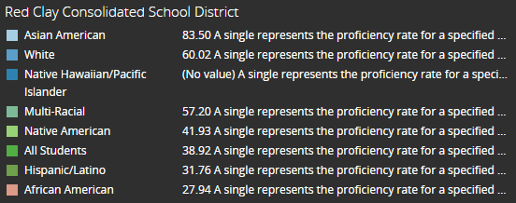
Above is Average % Proficient by Race/Ethnicity
ELA Proficiency by Race/Ethnicity
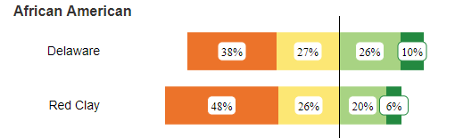
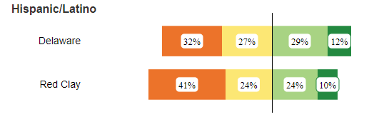
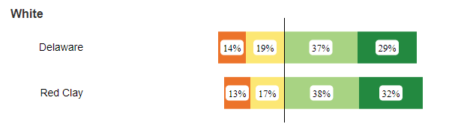
ELA Proficiency – Other Characteristics
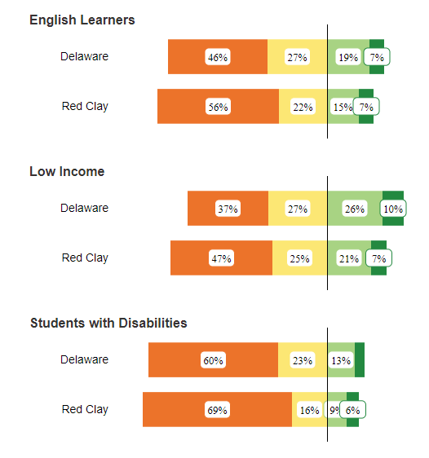
Math Proficiency by Race/Ethnicity

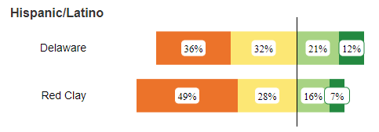
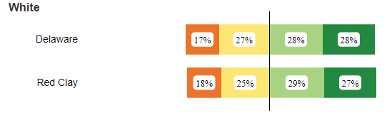

Math Proficiency by Other Characteristics
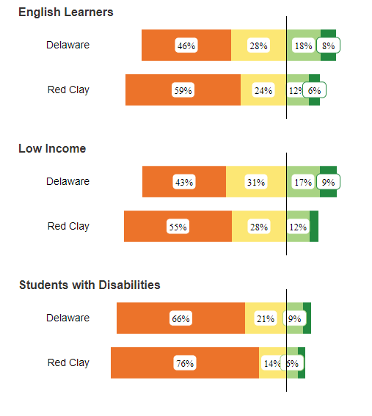
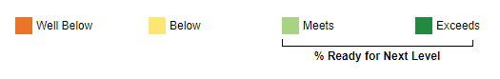

Kent School Districts
1. Caesar Rodney – Seat up for Mr. Mike Marasco, Board President; First elected 2016, two children in school
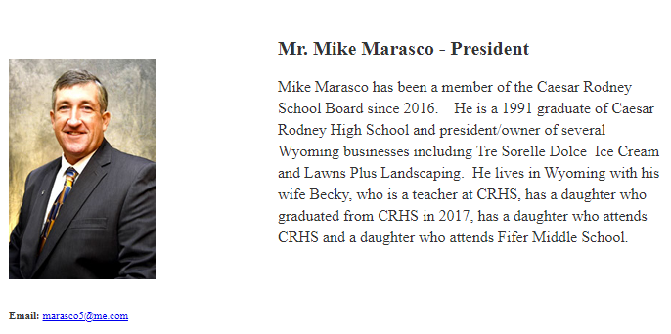
Problem – No Board Diversity
- Board is all white, 4 males & 2 females, tilts older;
- District with 8,183 students (Largest in Kent):
- 25.77% Black students, 9.21% Hispanic students, 7.3% Multi-Racial students, and 3.14% Asian American students; 26.24% of students are low income in this district
Problem – Opportunity Gaps identifiable in data by race/ethnicity, ELA, income level and students with disabilities
DOE Report Card Caesar Rodney – This presents a 64.09% ELA and 48.09% Math proficiency;
Yet if you look at Delaware Open Data Online – 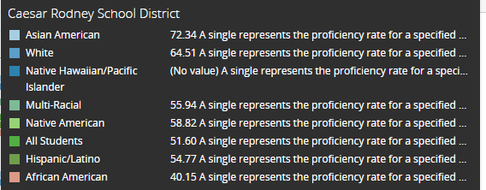
Above is Average % Proficient by Race/Ethnicity
ELA Proficiency by Race/Ethnicity
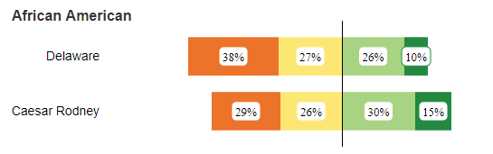
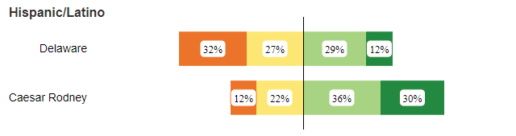
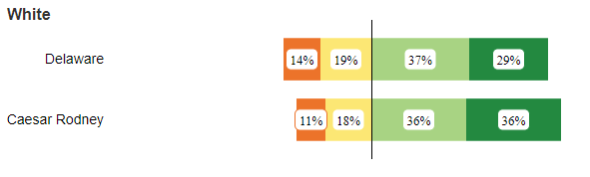

ELA Proficiency – Other Characteristics
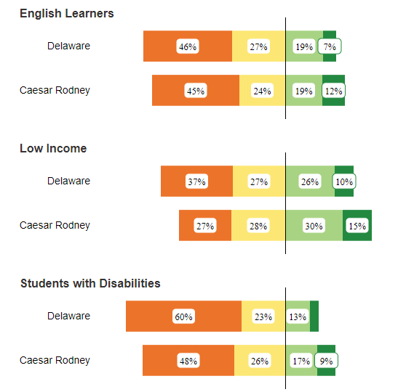

Math Proficiency by Race/Ethnicity
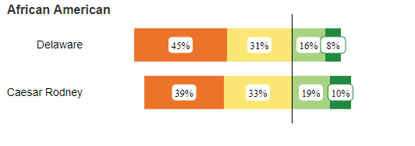
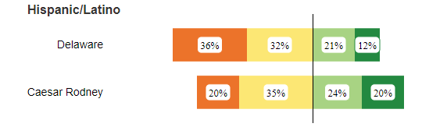
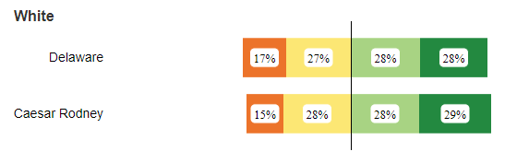

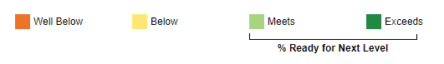

Math Proficiency by Other Characteristics
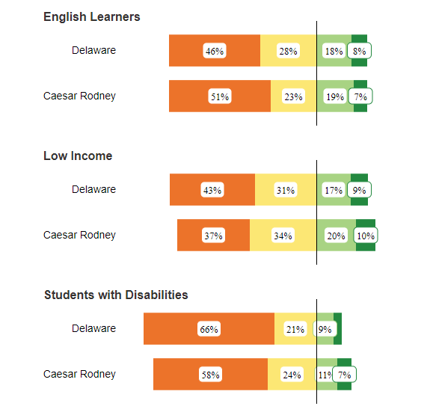

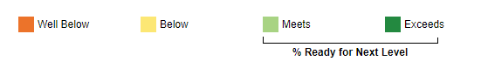

2. Capital – Seat up for Dr. Chanda Jackson-Short, Board President
Problem – Definite Opportunity Gaps Present
- Board is 60% White, but student population is 26% White;
- District with 6,605 students:
- 52.08% Black students, 13.37% Hispanic students, 5.19% Multi-Racial students, and 2.35% Asian American students; 43.83% of students are low income in this district; 21.56% students with disabilities; 7.8% ELA
Problem – Opportunity Gaps identifiable in data by race/ethnicity, ELA, income level and students with disabilities

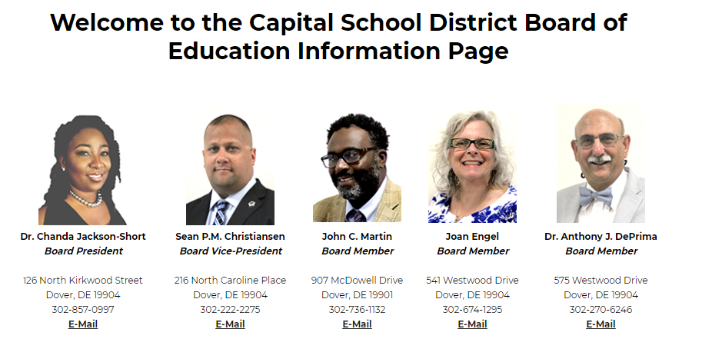
DOE Report Card Capital - This presents a 43.3% ELA and 31.26% Math proficiency;
Yet if you look at Delaware Open Data Online –
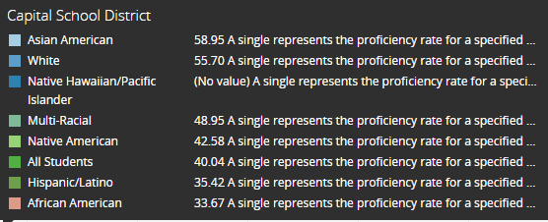
Above is Average % Proficient by Race/Ethnicity

ELA Proficiency by Race/Ethnicity
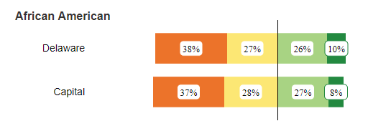
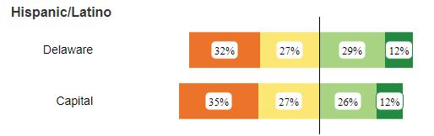
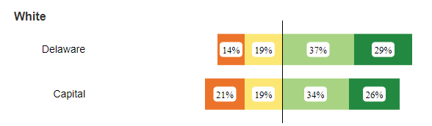

ELA Proficiency – Other Characteristics
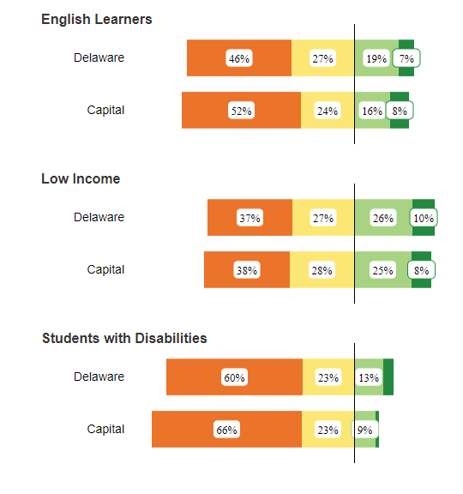

Math Proficiency by Race/Ethnicity
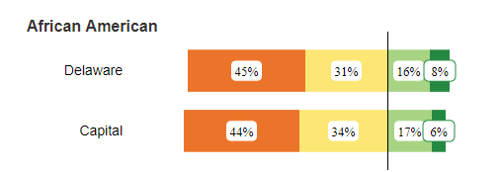
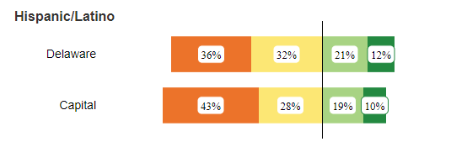
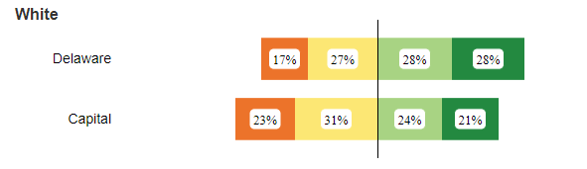

Math Proficiency by Other Characteristics
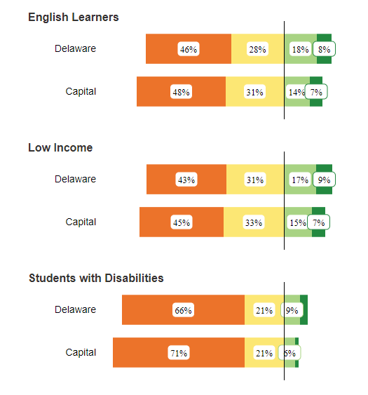

3. Lake Forest – Seat up for Mr. Earle Dempsey, Board President
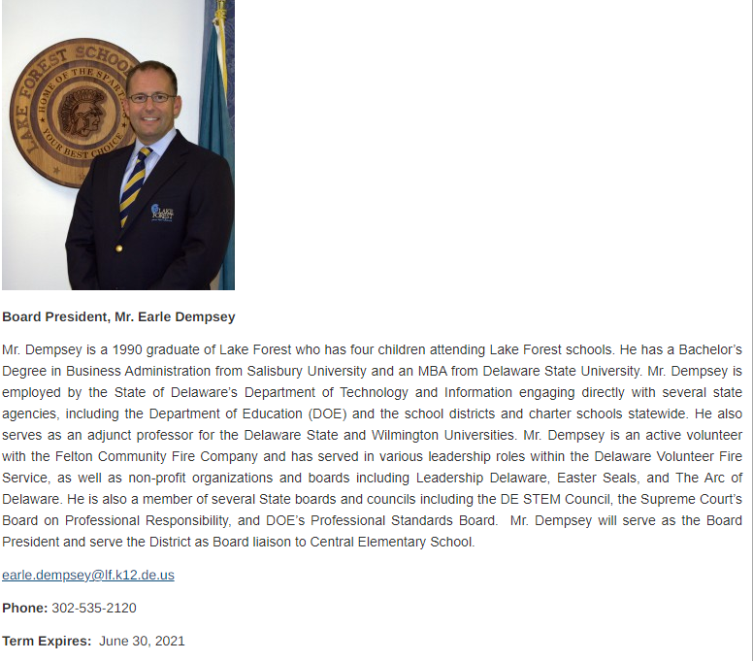
Problem – Smaller District with Sizeable Opportunity Gaps
- District with 3,721 students:
- 21.80% Black students, 8.06% Hispanic students, and 7.2% Multi-Racial students; 34.43% of students are low income in this district
Problem – Opportunity Gaps identifiable in data by race/ethnicity, ELA, income level and students with disabilities
DOE Report Card Lake Forest – This presents a 57.62% ELA and 49.27% Math proficiency;
Yet if you look at Delaware Open Data Online –
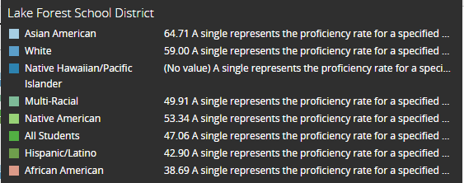
Above is Average % Proficient by Race/Ethnicity
ELA Proficiency by Race/Ethnicity
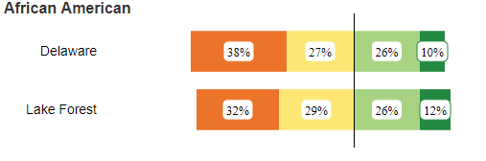
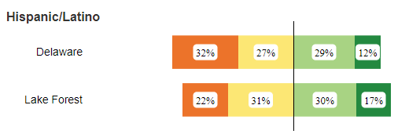
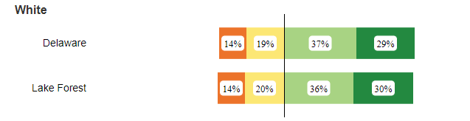

ELA Proficiency – Other Characteristics
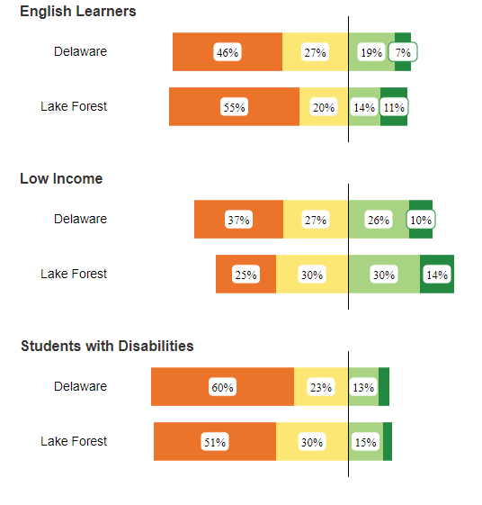
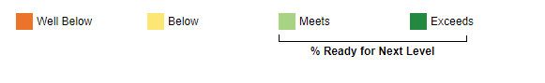

Math Proficiency by Race/Ethnicity
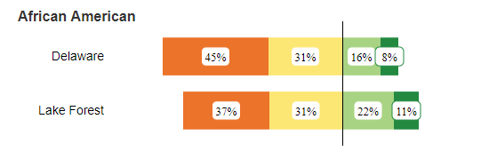
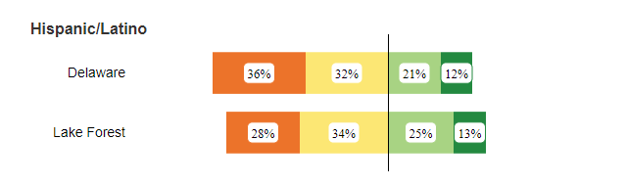
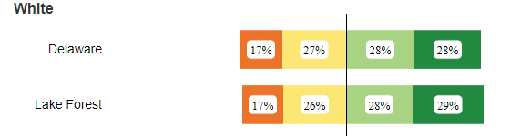

Math Proficiency by Other Characteristics
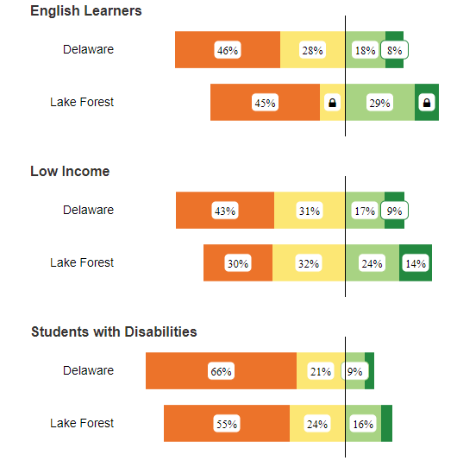

4. Milford– Seat up for Renate Wiley, Area C
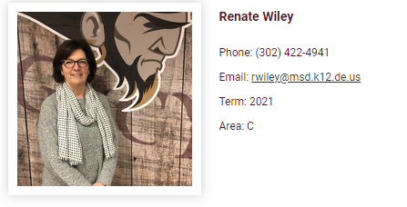
Problem – Definite Opportunity Gaps Present
- Board looks to be 83% White, but student population is 48% White; One Board seat is left unoccupied (Area D)
- District with 4,301 students:
- 24.9% Black students, 21.25% Hispanic students, 4.32% Multi-Racial students; 37.22% of students are low income in this district; 14.67% students with disabilities; 17.93% ELA
Problem – Opportunity Gaps identifiable in data by race/ethnicity, ELA, income level and students with disabilities
DOE Report Card Milford – This presents a 51.05% ELA and 43.86% Math proficiency;
Yet if you look at Delaware Open Data Online –
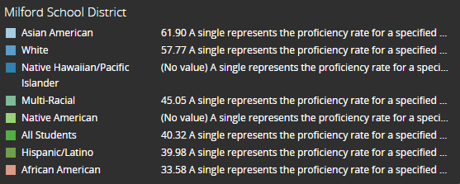
Above is Average % Proficient by Race/Ethnicity
ELA Proficiency by Race/Ethnicity
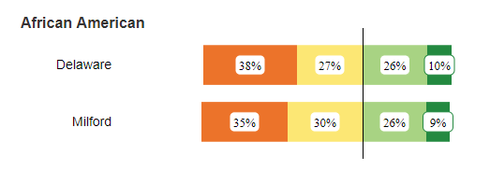
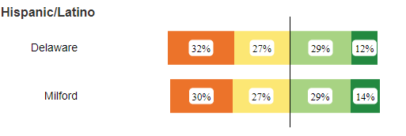
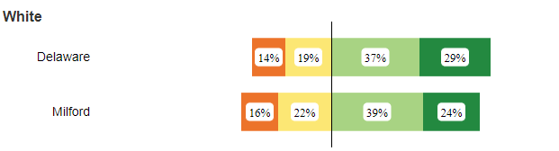
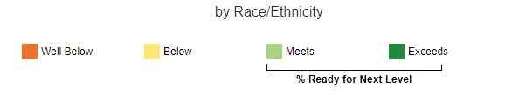

ELA Proficiency – Other Characteristics
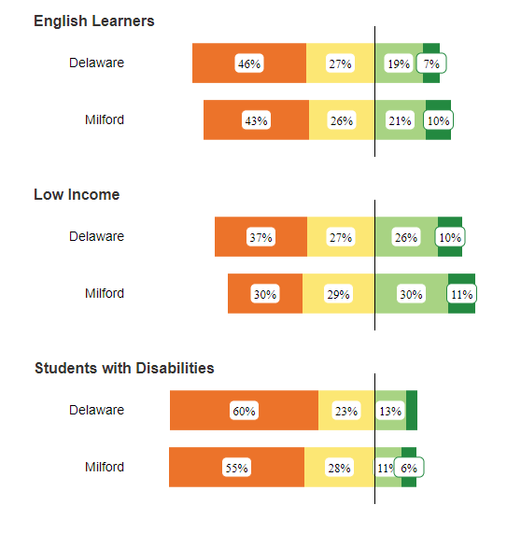

Math Proficiency by Race/Ethnicity
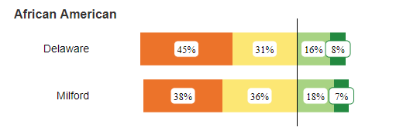
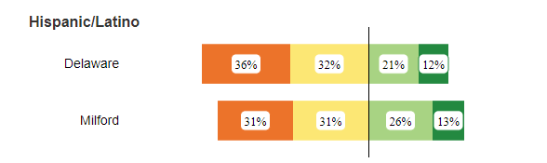
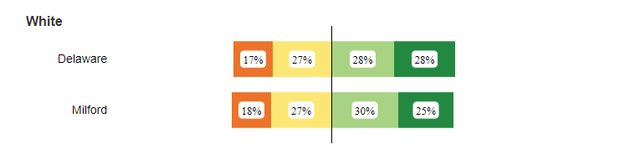

Math Proficiency by Other Characteristics
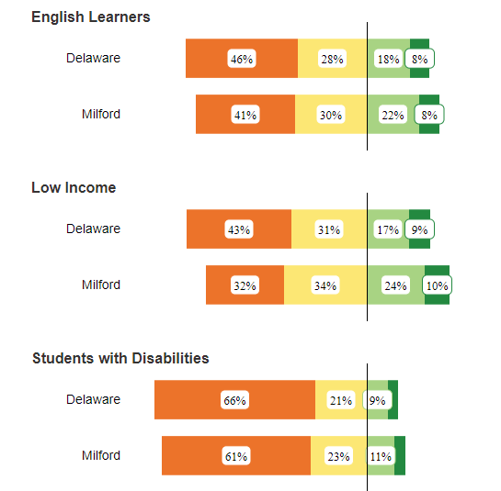

5. Smyrna– Seat up for Kathryn O’Connell, Board President – ran unopposed in 2016
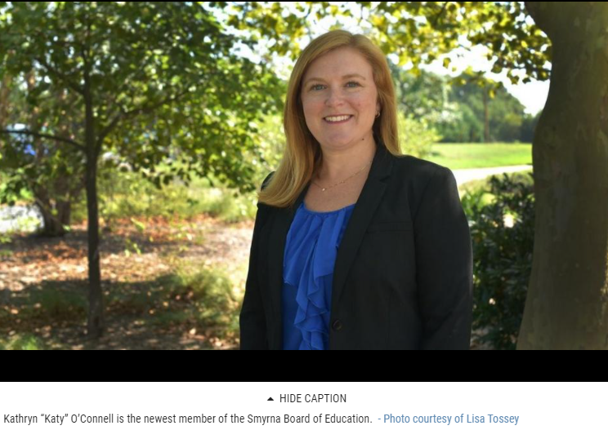
Other Board Members
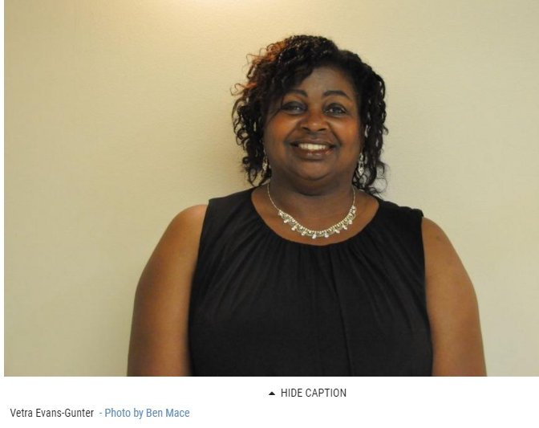
Vetra Evans–Gunter 2017 – won against Sweeney
Vetra Evans–Gunter 2009 – appointed to fill seat after a resignation
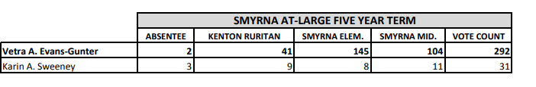
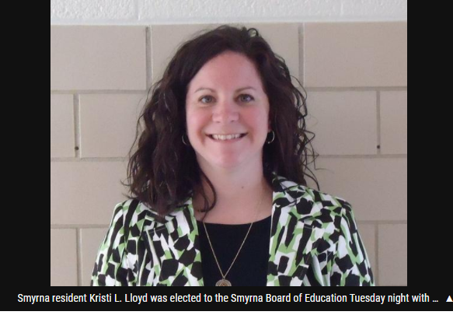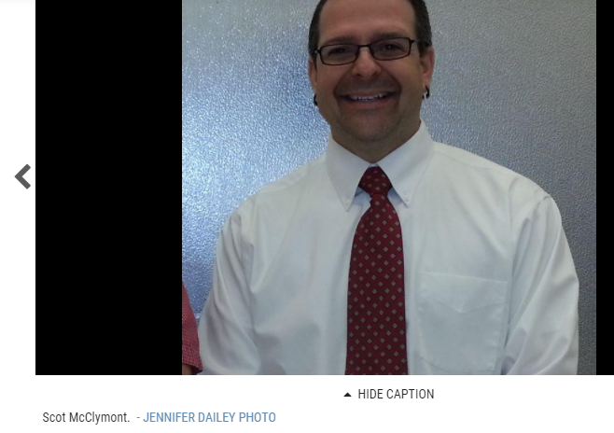
- Kristi Lloyd 2013 – won with 269 votes/ among 4 candidates
May 8, 2018 – won against Dodge
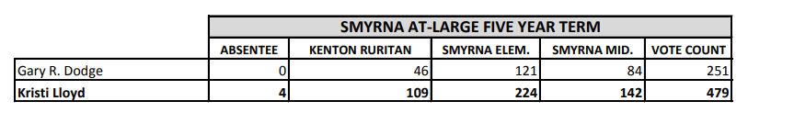
- Scott McClymont 2014 – ran against Jody Wilson

Scott McClymont 2019 – unopposed

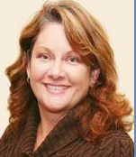
Christine Malec – first elected to school board in 2000; ran for District 28 House Rep 2007, Republican Candidate : Ran for re-election 2010; 2015, ran unopposed; 2020 - ?
Problem – Definite Opportunity Gaps Present
- District with 5,882 students:
- 29.31% Black students, 8.14% Hispanic students, 3.21% Multi-Racial students; 21.74% of students are low income in this district; 17.26% students with disabilities; 2.28% ELA
Problem – Opportunity Gaps identifiable in data by race/ethnicity, ELA, income level and students with disabilities
DOE Report Card Smyrna – This presents a 56.11% ELA and 47.4% Math proficiency;
Yet if you look at Delaware Open Data Online –
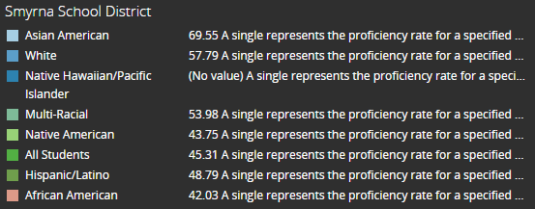
Above is Average % Proficient by Race/Ethnicity
ELA Proficiency by Race/Ethnicity
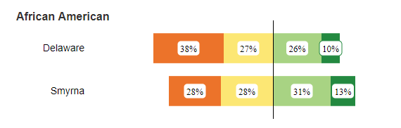
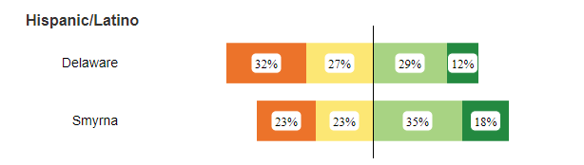
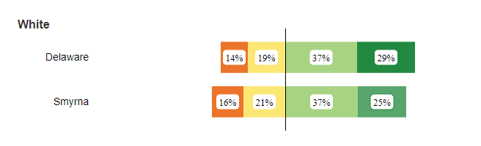

ELA Proficiency – Other Characteristics
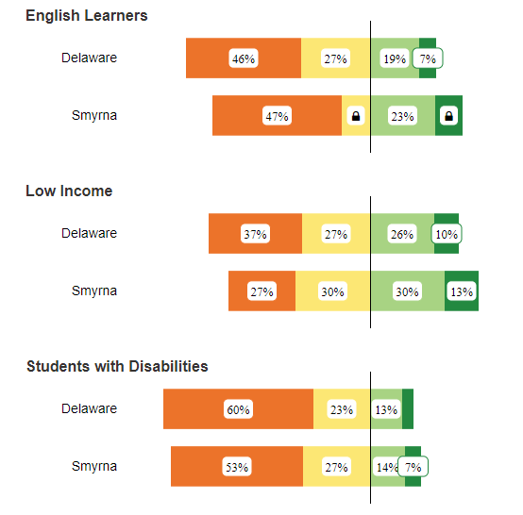

Math Proficiency by Race/Ethnicity
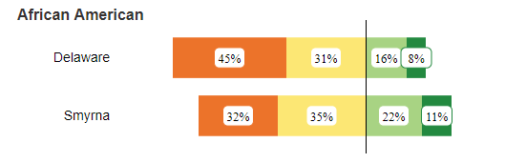
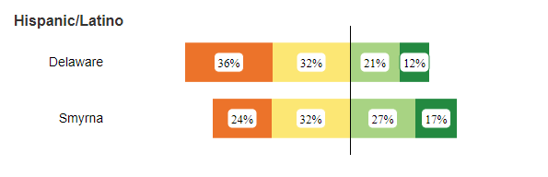
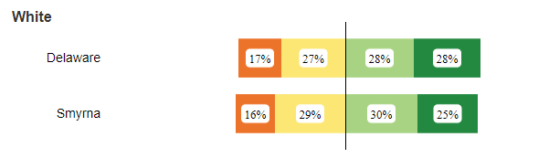

Math Proficiency by Other Characteristics
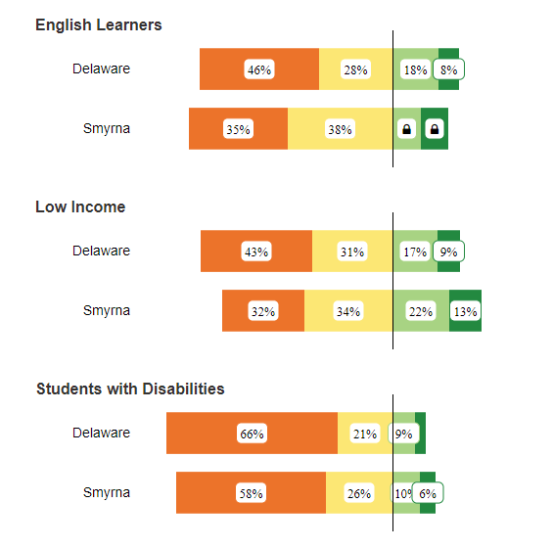
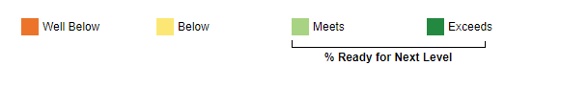

Sussex School Districts
1. Cape Henlopen – Seat up for Dr Janis Hanwell
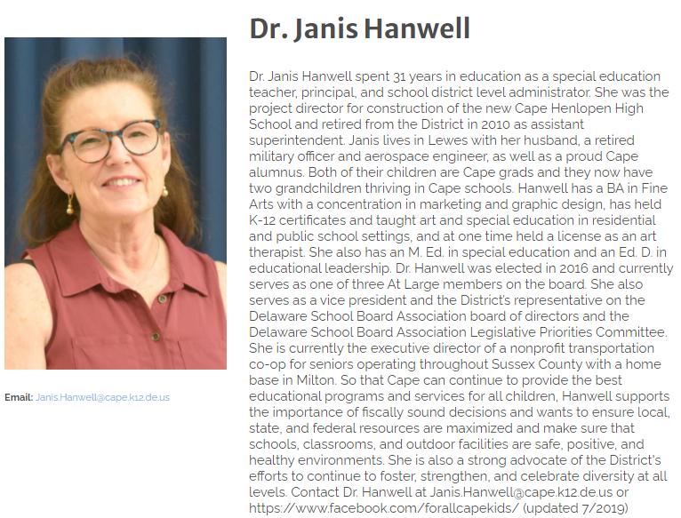
Problem
- District with 5,860 students
- 11.42% Black students, 15.65% Hispanic students, 3.82% Multi-Racial students, and 1.71% Asian American students; 22.08% of students are low income in this district; 17.54% students with disabilities; 8.34% ELA
Problem – Opportunity Gaps identifiable in data by race/ethnicity, ELA, income level and students with disabilities
DOE Report Card Cape Henlopen – This presents a 65.97% ELA and 56.6% Math proficiency;
Yet if you look at Delaware Open Data Online –
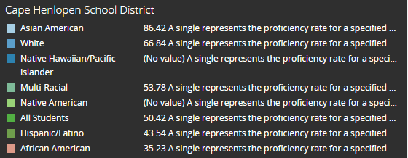
Above is Average % Proficient by Race/Ethnicity
ELA Proficiency by Race/Ethnicity
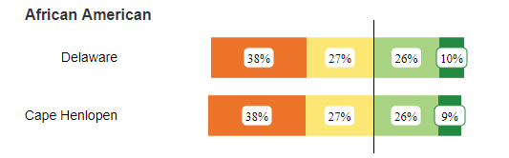
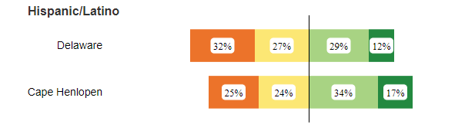
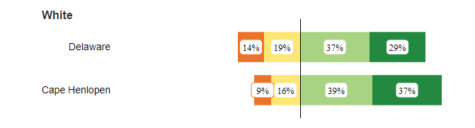

ELA Proficiency – Other Characteristics
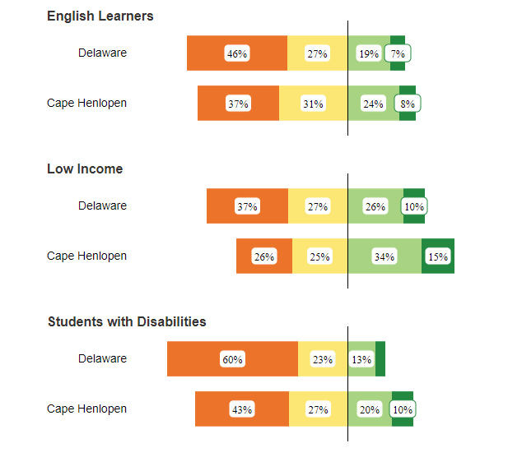

Math Proficiency by Race/Ethnicity
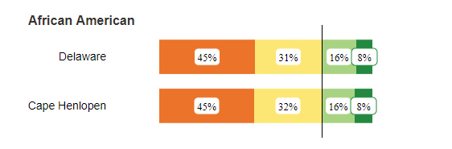
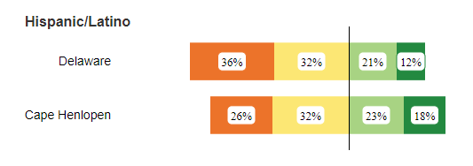
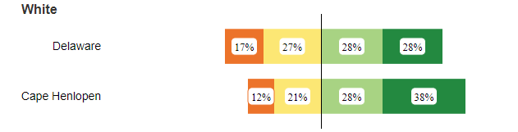

Math Proficiency by Other Characteristics
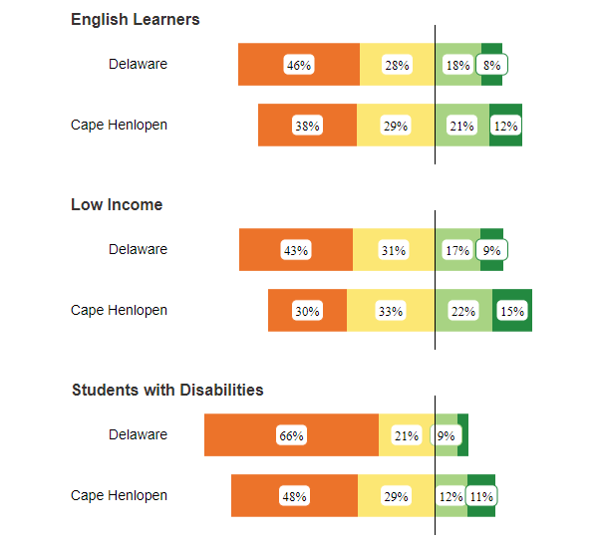

2. Delmar – Seat up for Farrah Morelli, Vice-President; Shawn Brittingham
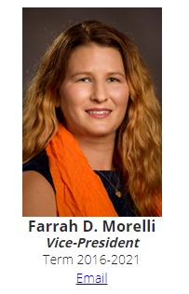
Problem – Seemingly No Board Diversity, except gender
- District with 1,405 students
- 14.80% Black students, 10.46% Hispanic students, 6.90% Multi-Racial students, and 2.92% Asian American students; 12.46% of students are low income in this district; 9.82% students with disabilities; 3.84% ELA
Problem – Opportunity Gaps identifiable in data by race/ethnicity, ELA, income level and students with disabilities
DOE Report Card Delmar – This presents a 51.16% ELA and 41.46% Math proficiency;
Yet if you look at Delaware Open Data Online
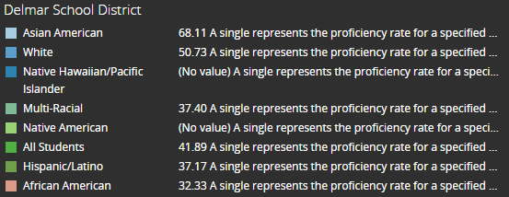
Above is Average % Proficient by Race/Ethnicity
ELA Proficiency by Race/Ethnicity
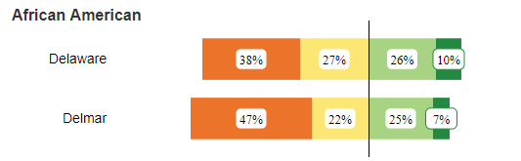
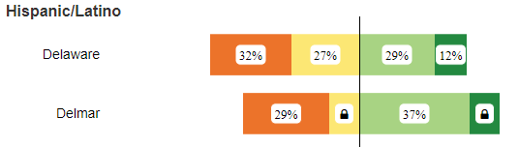
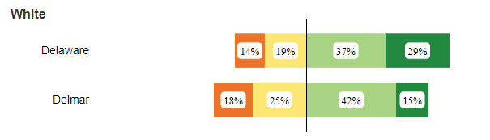
ELA Proficiency – Other Characteristics
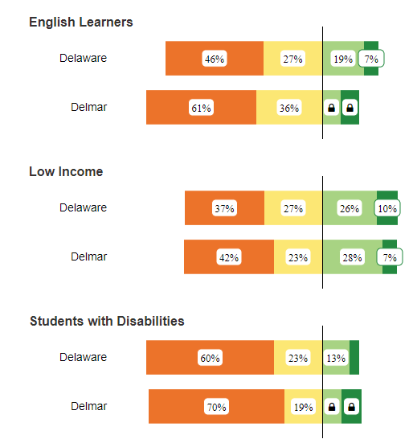

Math Proficiency by Race/Ethnicity
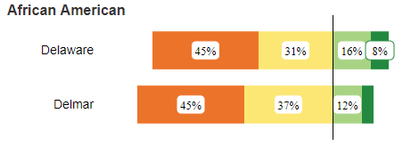
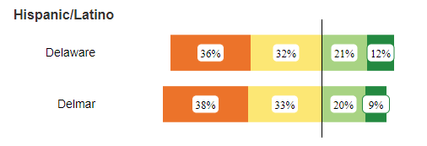
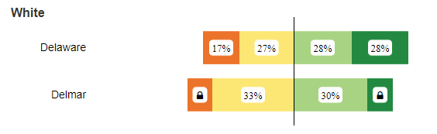
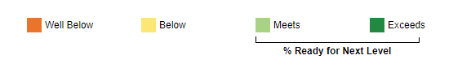

Math Proficiency by Other Characteristics
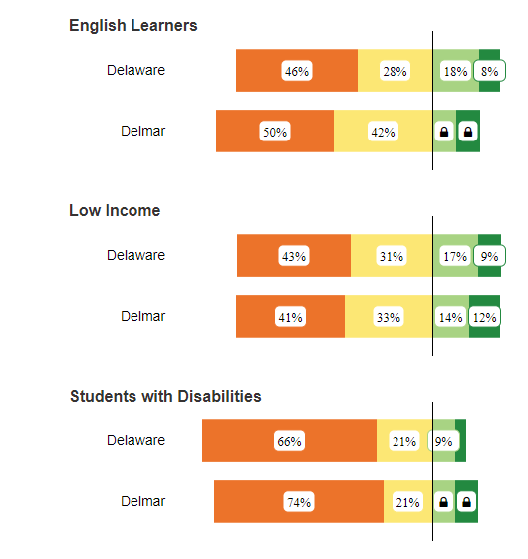
3. Indian River – Next Election is June 2023, 2 seats up for election: Rodney M Layfield, President (District 2), and Leolga T. Wright, Vice President (District 3). This Board has ten members, twice the number of some boards as 2 members come from each District.
Articles:
Groundbreaking held for new $45 million Howard T. Ennis School – No 25, 2020; this is quite a facility, read article for details, will serve students with significant disabilities from preschool through age 21; set on 32.5 acres; discussions for school started in 2015 and expected completion September 2022; that is efficient for such a large project
July 3rd, 2020, Candidates for District 4 – From the article’s layout/focus, you may think Goldman would be the winner; you’d be wrong – Constance Pryor won
Important Details of School Board 2020 Changes
Feb 2020 Referendum - Result
Problem – Low voter turnout, very unique board system that reflects a tight knit community; For a community with long standing traditions (Board Member Birley was involved for 43 years & fairly recently retired) – there is no information/photos/bios about the board members on the District website; Several members got their start on the Board as appointees for various reasons, and seats often are unopposed; however, one of the main challenges for this district is growth and overcrowding (it took 3 times to pass the referendum for a major capital improvements that included a new 2,200 capacity HS) – including a more diverse member that reflects the changes happening to promote inclusion would be a change from historic electsions; I believe Indian River is the only District in Delaware that is divided into 5 areas (also called Districts) where only the people living in that portion of Indian River can vote for that District’s seat. In other School Districts subdivided into areas – only candidates from the area can run for that seat, but then everyone in the District as a whole can vote for the candidate
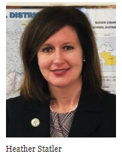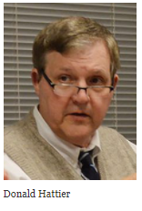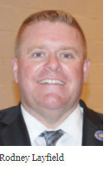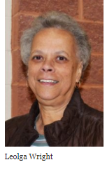
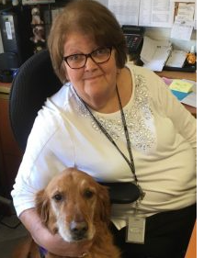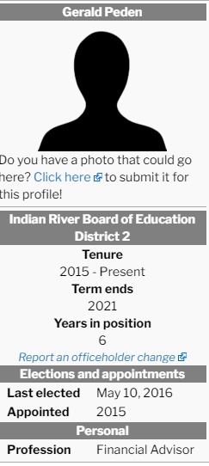
Connie Pryor Gerald Peden Leo J Darmstadter III (?)

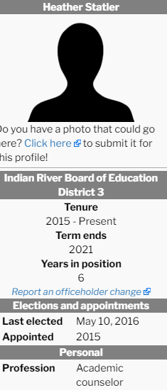
Derek Cathell
*Unable to locate photos for W Scott Collins, Gerald Peden, and Anthony L Cannon
- District with 10,942 students (Largest in Sussex, 6th largest in State):
- 11.05% Black students, 36.83% Hispanic students, 3.92% Multi-Racial students, and 1.14% Asian American students; 27.1% of students are low income in this district; 16.86% students with disabilities; 22.61% ELA
Problem – Opportunity Gaps identifiable in data by race/ethnicity, ELA, income level and students with disabilities
DOE Report Card Indian River – This presents a 59.01% ELA and 52.69% Math proficiency;
Yet if you look at Delaware Open Data Online –
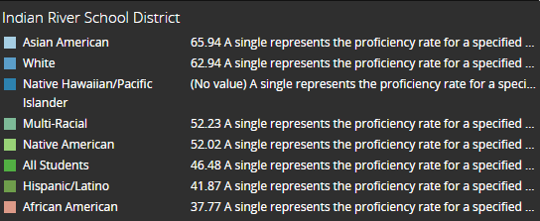
Above is Average % Proficient by Race/Ethnicity
ELA Proficiency by Race/Ethnicity
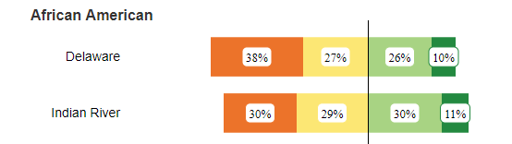
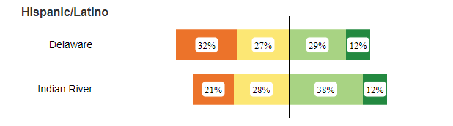
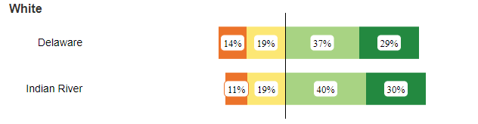

ELA Proficiency – Other Characteristics
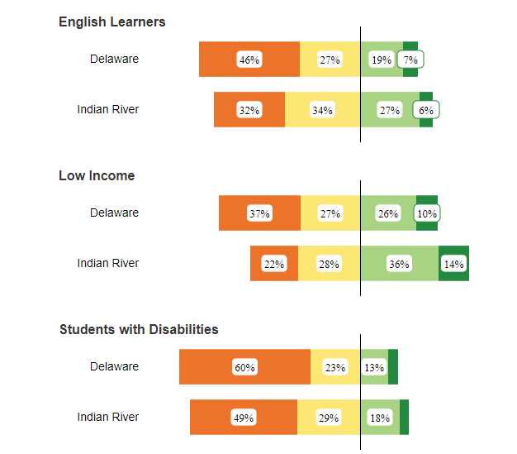

Math Proficiency by Race/Ethnicity
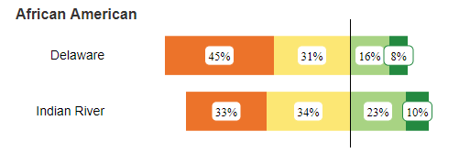
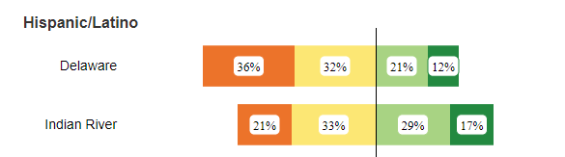
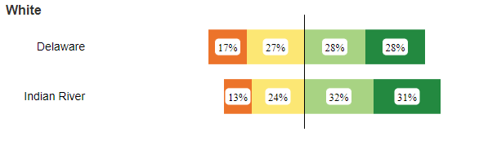
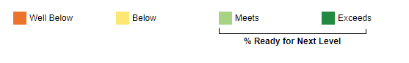

Math Proficiency by Other Characteristics
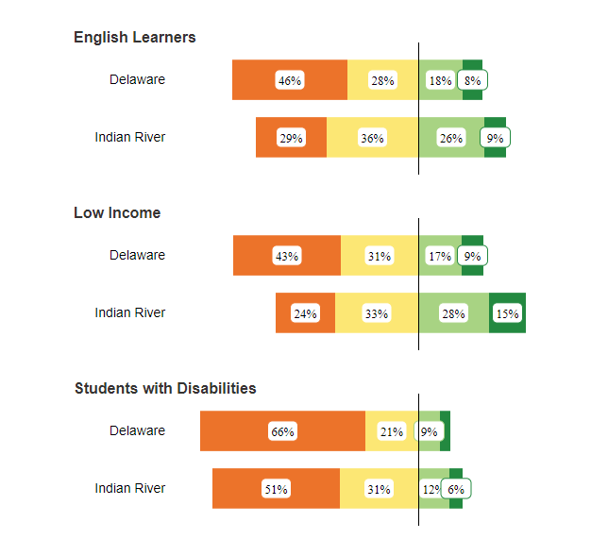
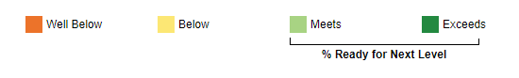

4. Laurel – Seat up for Mr. Shane E. McCarty
Problem – Definite Opportunity Gaps Present
Board:
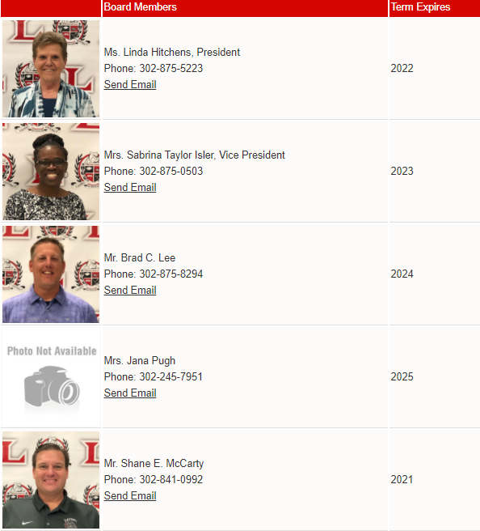

- District with 2,645 students:
- 26.28% Black students, 16.79% Hispanic students, 6.24% Multi-Racial students; 41.13% of students are low income in this district; 15.69% students with disabilities; 14.29% ELA
Problem – Opportunity Gaps identifiable in data by race/ethnicity, ELA, income level and students with disabilities
DOE Report Card Laurel - This presents a 46.13% ELA and 37.18% Math proficiency;
Yet if you look at Delaware Open Data Online –
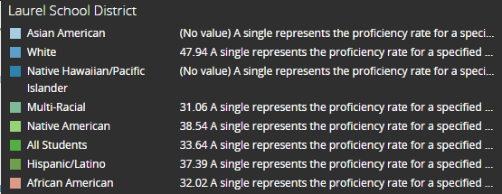
Above is Average % Proficient by Race/Ethnicity

ELA Proficiency by Race/Ethnicity
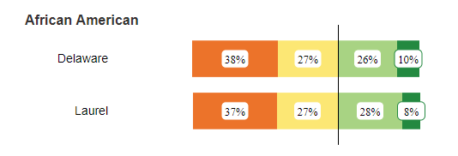
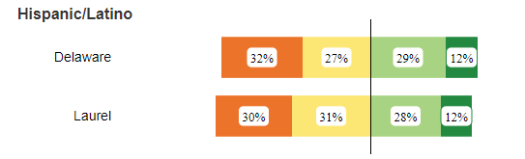
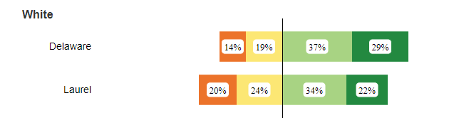

ELA Proficiency – Other Characteristics
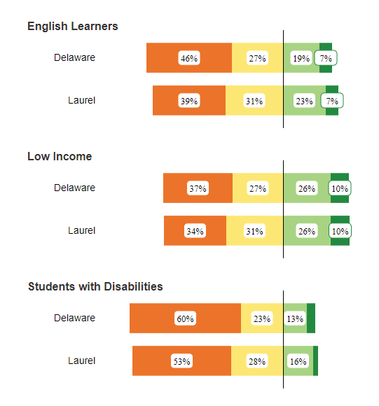
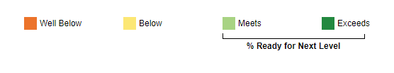

Math Proficiency by Race/Ethnicity
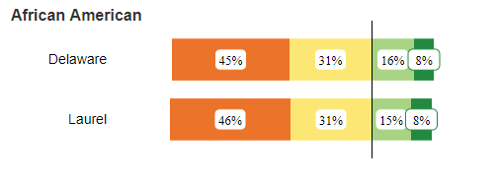
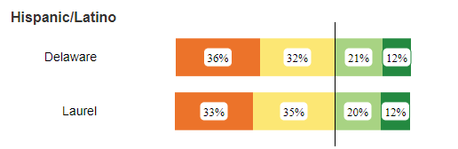
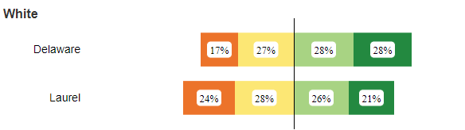

Math Proficiency by Other Characteristics
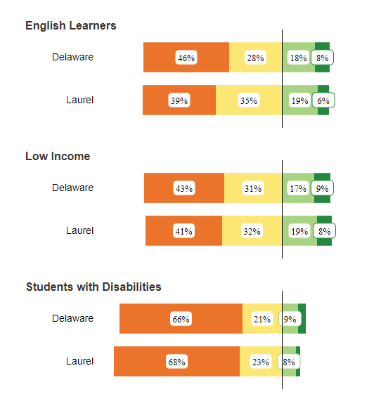

5. Seaford– Seat up for Mrs. Kimberly Hopkins, Vice President
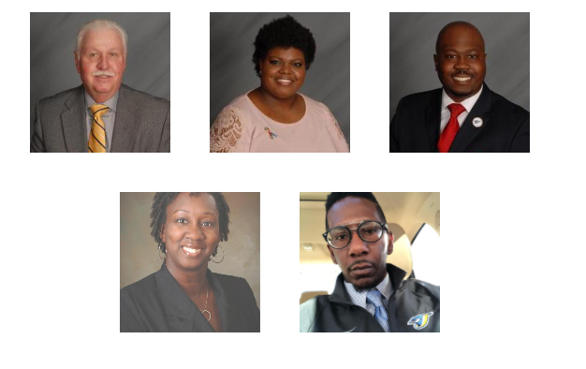
Problem – Definite Opportunity Gaps Present
- District with 3,516 students:
- 35.95% Black students, 23.04% Hispanic students, 6.85% Multi-Racial students; 42.43% of students are low income in this district; 17.89% students with disabilities; 18.91% ELA
Problem – Opportunity Gaps identifiable in data by race/ethnicity, ELA, income level and students with disabilities

DOE Report Card Seaford – This presents a 52.58% ELA and 44.34% Math proficiency;
Yet if you look at Delaware Open Data Online –
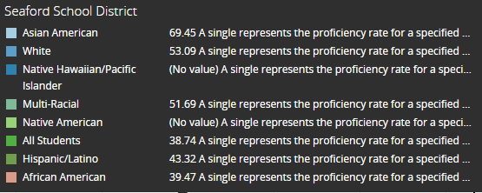
Above is Average % Proficient by Race/Ethnicity

ELA Proficiency by Race/Ethnicity
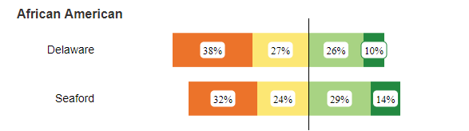
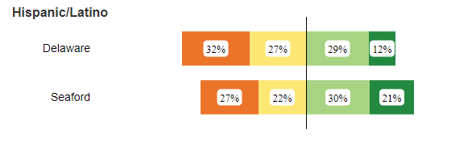
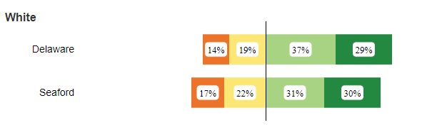

ELA Proficiency – Other Characteristics
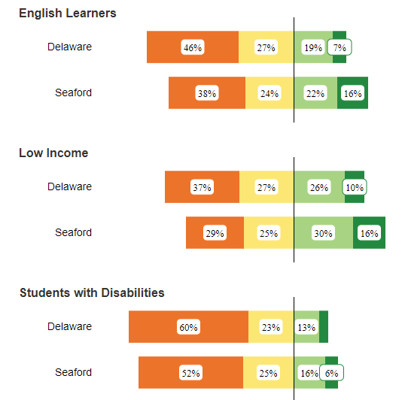

Math Proficiency by Race/Ethnicity
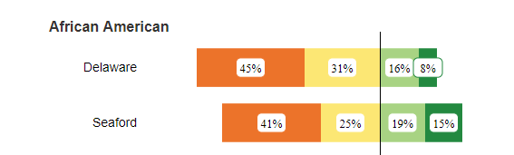
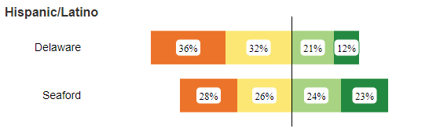
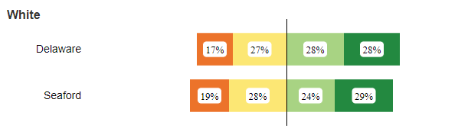

Math Proficiency by Other Characteristics
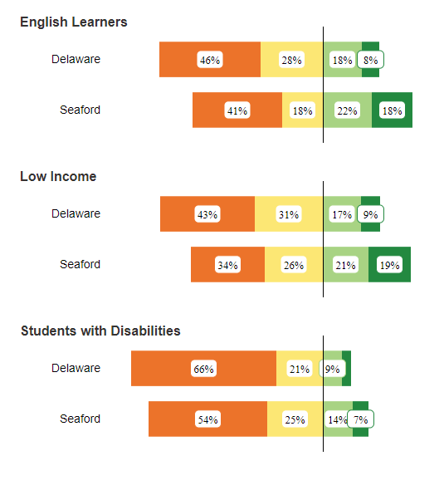
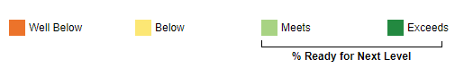

6. Woodbridge– Seat up for Danielle Taylor

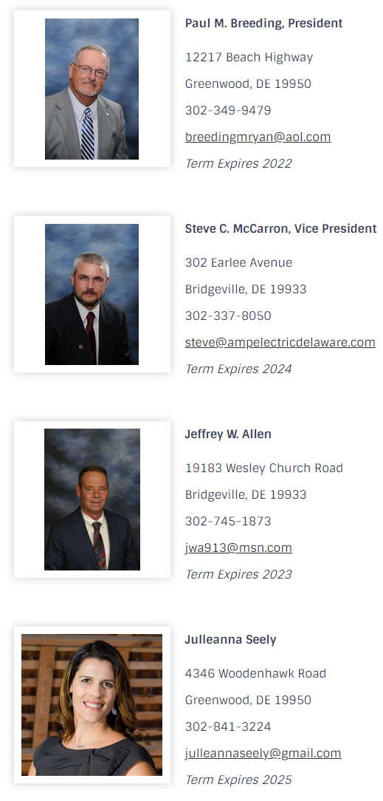
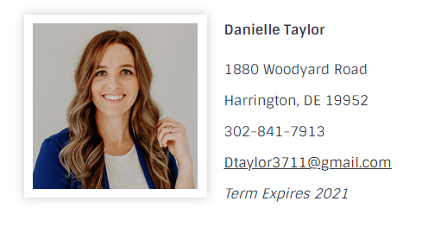
Problem – Definite Opportunity Gaps Present
- Board looks to be 100% White, but student population is 44% White
- District with 2,594 students:
- 21.36% Black students, 25.4% Hispanic students, 8.25% Multi-Racial students; 38.36% of students are low income in this district; 16.35% students with disabilities; 12.8% ELA
Problem – Opportunity Gaps identifiable in data by race/ethnicity, ELA, income level and students with disabilities
DOE Report Card Woodbridge – This presents a 38.81% ELA and 31.11% Math proficiency; These % are noticeably low as overall figures. I added a “By Grade” data point, so you could see that the number of students that exceed or meet proficiency expectations in the 11th grade is so low, for both ELA and maths, it’s a locked figure. By 8th – it’s at 7% (ELA) for exceeds and 27% (ELA) meets; 9% (Maths) meets and no figure presented for exceeds at Maths.
If you look at Delaware Open Data Online –
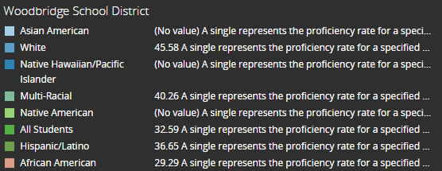
Above is Average % Proficient by Race/Ethnicity

ELA Proficiency by Race/Ethnicity
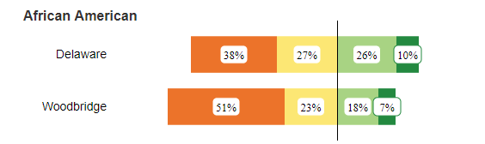
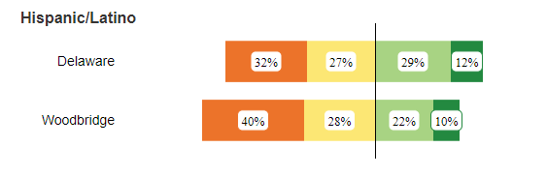
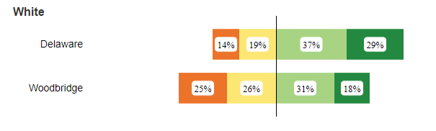

ELA Proficiency – Other Characteristics
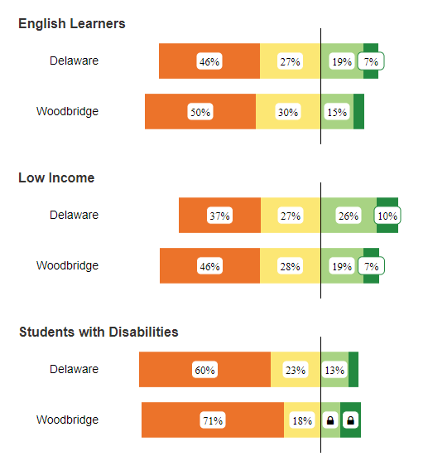

ELA Proficiency – By Grade
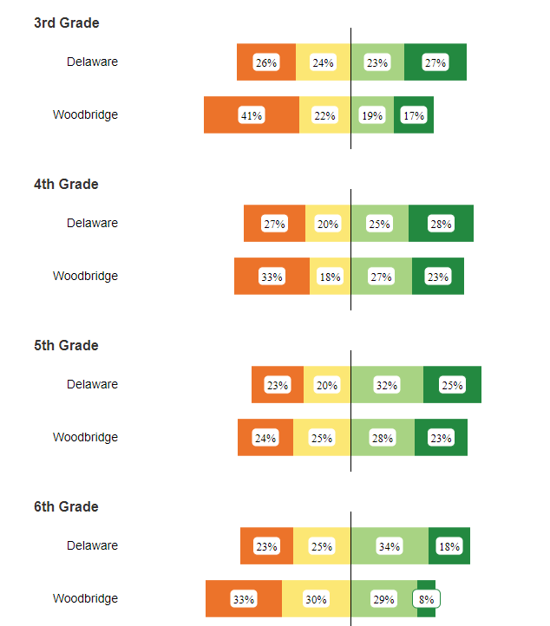
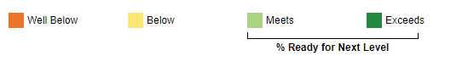

Woodbridge – By Grade cont.
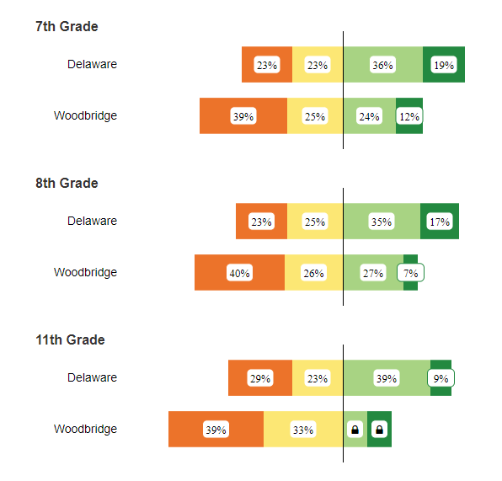

Math Proficiency by Race/Ethnicity
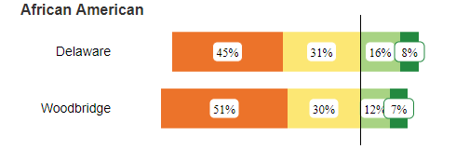
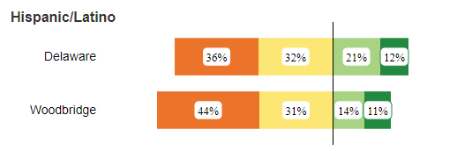
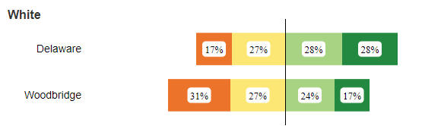
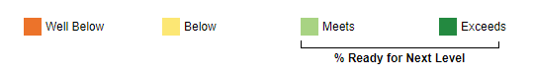

Math Proficiency by Other Characteristics
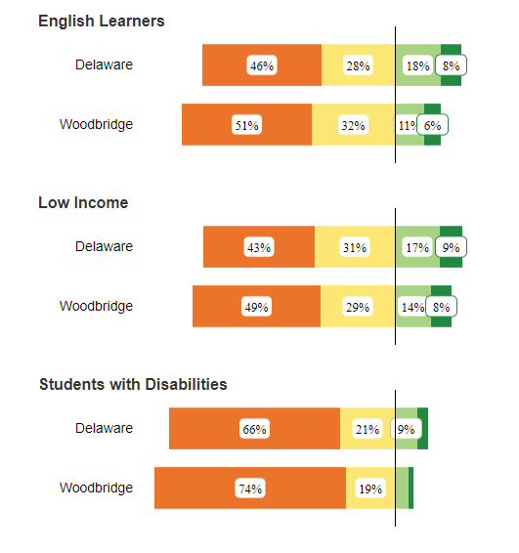

Math Proficiency By Grade
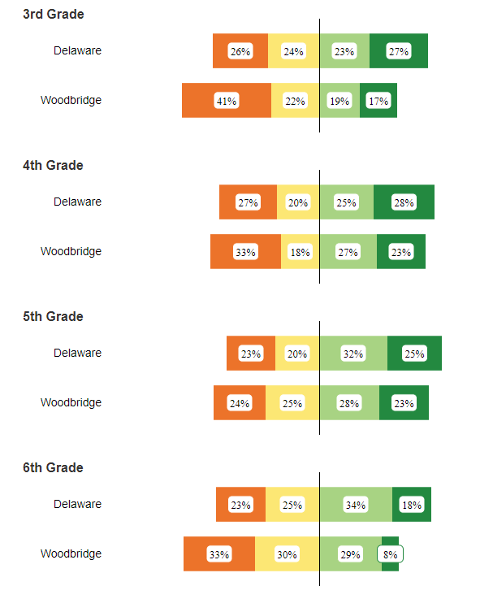

Math Proficiency By Grade Continued
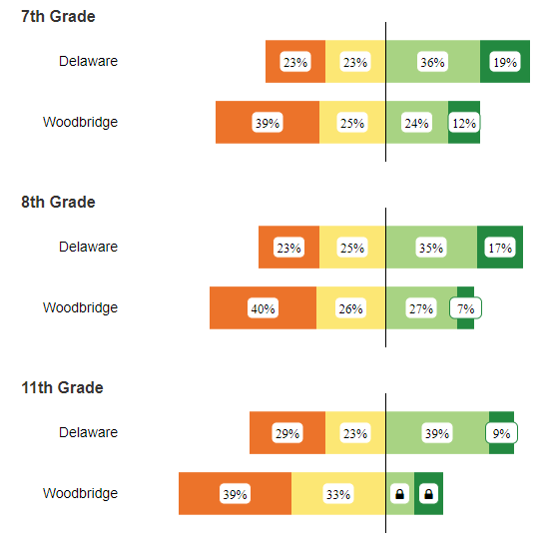

Appendix, Carney & Street at Redding Consortium
Governor John Carney, Settlement in State Education Equity Lawsuit, October 22nd, 2020, Link, 00:08:36 – 00:18:14
Yeah. Thank you, Senator Lockman, and thank you for the work that you're doing with all the other members on the Consortium. I didn't hear that your co-chair, Matt Den, was on the line as well. But thank you to him. Special thanks to Jea Street of who I think you're going to hear from in a couple minutes after I'm finished into Freeman Williams and the ACLU legal team who are involved in, in this, this settlement.
I would, I would like to kind of set the context because I see the settlement does another very positive step, really important step, in our efforts to, to do the best we can for every child in our state, no matter what circumstances they find themselves in. Going back to my early days as Lieutenant Governor was when the first test scores and accountability regime were actually having a real impact.
And we saw early on there, there were significant differences between children of color and those not, between children with - more affluent children, than less affluent. We ran a program to identify different programs in our state that we're proving successful in narrowing what became known as the achievement gap. I like to think of it as the opportunity gap. That's really where I first met Dr. Susan Bunting in the great work that they were doing at Indian River in doing just that. Narrowing that gap. So, it's a commitment that I have had going way back when I was elected and we took over in 2017, we had a lot of work that was done by Tony Allen's group, The Wilmington Educational Improvement Commission. Some of those members are on your Consortium.
And thanks to, to each of them for, for their hard work over the years. There are a number of things in there that people want to know what I was going to do. First among them was the whole redistricting question, which had kind of not been approved, after being approved by the Christina Board or Red Clay Board with some caveats when one chamber in the House of Representatives, not the other.
And then there are another really important recommendations. Chief among them, I think additional resources for children from disadvantaged backgrounds and English learners.
After meeting with so many stakeholders, many of whom are, are on the call, the former superintendents of each of the four districts, uh five districts, all of which have been replaced by the current incumbents in those positions. Meeting with the President of those boards and some members of those boards, we were on a, I was unable to get a consensus around what's the best way to, to redistrict the districts here in New Castle County with respect to the Wilmington schools.
Everybody kind of agreed that it didn't make much sense anymore for Christina to be part of that mix, as, as was kind of recommended by WEIC.
And so, we decided, uh, Dorrell Green at the time, who came in to head up our Office of Educational Innovation and Improvement, working with Secretary Bunting they visited all the schools in the city of Wilmington.
And they determined that they were all falling a little bit short, but the ones that needed the most help were the five Wilmington schools in the Christina School District.
In Secretary Buntings recommendation, time is flying by. Children are moving from one grade to another every year. Let's really focus on improving what's happening in those schools. Let's recapitalize the buildings and rationalize the number of buildings they have. They had only enough students, they have five buildings, only enough students for two. And so, we went through that whole process. I knocked doors on the east side and the west side, trying to get parents to engage and come to our town hall meetings.
Ultimately, we came up with a Memorandum of Understanding to move forward and work with Christina, as Dorrell did with that team and Jim Simmons today.
All along, we wanted to, really the most important thing, proposal, coming out of the WEIC was what was weighted student funding. So, we created the first year, notwithstanding, a $400 million deficit, in a nominal way for sure, what we call opportunity funding, which was the first funding we've had in our state that goes to schools are based on the enrollment number of children with this, with English learners and those from disadvantaged backgrounds.
The next year, and leading up to that budget presentation in January of 2019, we were, we went and dramatically improved, added to the opportunity funding, $20 million a year over a three year commitment wasn't weighted to, directly weighted, and it wasn't permanent, which was intentional on my part. I didn't want to just throw money at the problem. I wanted the districts to really be thoughtful about how they were using it. I wanted them to report back to a committee that looked at all those programs, so that we could move forward with the best way of adding additional resources to the schools.
In December, mid, mid-December that year, I got a call from my good friend Jea Street who I had met with before a couple of times and discussing both the redistricting thing and the funding thing, and he wanted to give me a heads up that he and the ACLU were suing me and the State over the inadequacy, if you will, of what the State of Delaware does for children from disadvantaged backgrounds and English learners.
I was eager, frankly, to talk, to tell the judge what we were doing and go through all that. Became very clear, pretty early on, that all's we were going to end up doing was spending a lot of money on lawyers, wasting a lot of time, again, and maybe not ending up with anything.
So, the judge encouraged our lawyers to agree to a mediation process, which we did, because I knew that the interests of the plaintiffs, Jea in particular and Freeman, who I know well, were completely aligned with what I wanted to see happen as Governor.
And so, we did work over a number of, well months. The lawyers did - me and, and the plaintiffs on the other side over a series of meetings of weeks, and essentially what we did was push to what was my limit. I said to Jea at one time, I said Jea, I am not going to agree to something I can't deliver. And it just to me, just doesn't make any sense. But we pushed and we pushed, and you're going to hear from Mike Jackson, so, that we made a commitment to increase opportunity funding from its current level of $25 million a year distributed based on students, to $60 million a year. So more than doubling it, which is really a stretch goal.
To add additional resources, have, as we have been doing to early childhood education because we know how important it is. In particular, ECAP, which is a program that targets a certain, students, to increase the resources that, and the funding, to attract teachers to teach in the more challenging environments in the city schools.
There was a proposal in the legislature that many people supported, to provide additional funding for K to Three, a basic special education, which is part of the agreement. Mike Jackson is on here; he can run you through all those elements.
At the end of the day, they pushed us, and I basically said, “Look, I can only do so much.”
Mike and I sat down. We knew we were in, in a very seriously bad financial position. So, the plaintiffs allowed us to structure this so it's, it's another year or two out, but the commitment is there for us to go to the legislature, frankly, and have those resources committed.
I was, always been optimistic because of the support that we've had for Opportunity Funding from those beginnings and because it helps schools in every part of our state. There are poor children in Laurel, in Shelbyville, in Seaford, in Dover, in Camden and Wilmington and suburban New Castle County.
And this, these resources, and our focus most importantly on using the resources to move the needle for these children, will make a big difference.
And I just want to thank Jea, again, for his long years of advocacy. I don't know what kind of relationship Jea and I have, but I figured if Jea and I can't do it, I don't know who can.
And we were able to push it over the goal line. I'm sure Jea is going to tell you he's not completely happy with it.
But, in the end, we wanted to spend money improving the education of children and not on lawyers, and of course, I was always concerned about a judge telling elected officials what to do.
So that, I know that's a little bit long. That's my, actually my Reader's Digest version. I went through several years pretty quickly. But I appreciate the opportunity to set that context.
And the context is simply this: our interest, my interest as Governor, my team's interest, Secretary Bunting, John Sheehan, who does great work, Mike Jackson, all of our team, our interests are completely aligned with the plaintiff’s interest, which is why we push hard to get that agreement.
So again, thanks to Jea and Freeman and the, to the ACLU lawyers as well.

Councilman Jea P. Street
Say, thank you, Senator, I appreciate the opportunity.
The Governor was correct, obviously, I wanted more.
We tried to get more, but we had to be realistic in, situation we're in with the pandemic, and reasonable in terms of, of working with the Governor and looking at what was realistic to put before the General Assembly during this, what I consider a crisis situation.
Um, I'm gonna go back. I am now 46 years, 10 months and 22 days in the arena.
Regrettably, I'm not going to be able to leave it better than I found it when there was a Wilmington School District.
But hopefully I can leave, and it will be better than it is today.
The genesis of this, unfortunately, is the lifting of the court order - the school desegregation order, which was officially lifted in November of 1996.
And the last page of Judge Robinson's Opinion In Order, said, “There's nothing in the record below to indicate that current school officials will return to the segregated ways of their predecessors.”
Unfortunately, before the ink was dry, that's just what they did.
They went first to: Charter School Act, Choice School Act - with no transportation - and then ultimately, the Neighborhood School Act.
Thanks to the Wilmington Metropolitan Urban League, under the leadership then of Jim Gilliam Sr., he insisted to the General Assembly, when the Neighborhood School Act was about to be inactive - or acted upon - that there be a neighborhood school committee to make recommendations.
Neighbors School Committee made recommendations, and those recommendations were: when you create all these high poverty schools, you need to have – (It was a universal concept, but the most outstanding as far I'm concerned was) - you needed a weighted funding formula for high poverty schools and a reduction in the number of districts in the City of Wilmington.
That legislation went to the City. City modified it a bit. It was submitted. General Assembly never acted.
In the meantime, by the time we get to the Wise administration, in 2005, in Christina - City schools were fully segregated.
And, in 2008, there was a Wilmington Education Task Force. It met, made recommendations. Among those recommendations were: a weighted funding formula for high poverty schools, a reduction in the number of districts in the City of Wilmington.
No legislation was sponsored. No action was taken.
And, the fact that we were resegregated inconsistent with the Brown decision, separate but equal being inherently unequal, we got to see and we were seeing - based on performance - of the inequality and its impact on low income children.
And at the time, we were primarily interested in the City of Wilmington.
We go forward in the WEIC Commission, made comparable recommendations. Legislation was passed in the House and was rejected in the Senate.
And so, we got to the point where, and I was trained by, especially Irvin Morris, and other lawyers involved in this litigation, that you only go to court as a last resort, that's what we did.
And I'm going to quote Bea Carroll when we had the Coalition to Save Our Children.
And we formed that, it started out as - called it, Save Our Schools.
We formed that in 1980 in response to the State's request to go from the County District to four Districts.
And during that period of time, when the Coalition to Save Our Children ended up being plaintiffs, Bea Carroll said, “This litigation is of, for and about children.”
And today, I reiterate that this settlement is of the litigation that created the settlement, and the settlement itself is of, for and about children, but not just children in the city of Wilmington.
Children throughout the entire state of Delaware, because as we did our research, it was crystal clear the children, not just in the City of Wilmington, but throughout the State were suffering and needing additional assistance. And we went forward accordingly.
I am grateful to the Governor, his legal counsel. Because I think we were all pushed, and I appreciate the assistance that we had from, from the mediator and taking us all to task.
And at the end of the day, no, - it's, I wanted a lot more.
I think our children deserve a lot more, but we had to be realistic.
And, quite frankly, at the end of the day, and you look at that last year, in the $60 million in Opportunity Funding and then the entire amount, just in that last year, and what I think is going to be coming forward from, as a result of the County litigation.
There was no way we can leave $100 million dollars on the table to help kids and just walk away from that to pick a fight that may have lasted two or three years.
And we purposefully and intentionally stayed away from the major task.
Um, and the reason for that is we didn't want to usurp what was going on with The Redding Consortium and, in my opinion, not representing any group that I have - your task is, is awesome.
Because you're going to hear different opinions. All the way to my opinion: that there should be one School District in New Castle County. At least, in the northern part of it.
You're going to hear people say: we should have a Wilmington School District, you going to hear people say that we should have all Charter Schools.
And you're going to hear people make a suggestion that, we have some other models.
Um, and I figured that, the young people in the General Assembly who are taking this, undertaking this leadership, could get their way through that fighting.
I would put our emphasis on the money.
Which is very, very important. The resources are very, very important.
And we were able to come to an agreement.
And I commend the Governor and his legal team.
I thank our legal team and our co plaintiffs, the NAACP, um, because we're - as the Governor indicated, we're all on the same page, as trying to do what's best for children.
This Governor, I don't want to talk about one of his predecessors in particular, but this Governor - didn't create this.
This General Assembly didn't create this.
But this General Assembly is now tasked to fixing what their predecessors, in my opinion, or because those three Acts, with all – of which had a segregative effect were passed by the General Assembly.
And the challenge that you're going to have now, is as the General Assembly looks at it - unfortunately, there's still some of that Old Guard running around Legislative Hall as lobbyists who didn't do anything to help our children when they were in office.
And they're going to be, I'm afraid, among the naysayers, um, but you've got to look past personalities, individuals, what happened in the past.
The question before the General Assembly is, “What's best for our children now? What can we do to be more responsible?”
And come forward, and, and pass something that we all agreed on.
And quite frankly, look at the data, and I see Mayor Purzycki sitting there.
We're already at 150 shootings in the City.
And we're not talking about people who - who are the shooters or the people getting shot -who were honor roll students on their way to college.
Um, and either we fix this with the resources that we're starting out with here. Or you're going, unfortunately, end up building another jail.
I'm so - I'm, I'm happy.
Excited about what we are able to accomplish.
And, hopefully, going forward it will - I'm - When I'm no longer playing in this arena, and everybody who has to make a decision now, is no longer playing - there'll be something there for those who follow in our footsteps, to be able to have to work with it.
It'll, It'll have some longevity to it - and benefit low income children, and children with special needs, for a long time to come.

Elizabeth Lockman
Thank you, Councilman. That really, you know, gave us the full picture.
And I thank both of you.
You know, for the work and the good of the negotiations that have gotten us to this point, but definitely it’s a daunting task. I had to navigate from here and, you know, figure out the way the resources are going to drive some of the other reforms that you talked about.
So, I want, I want to be mindful of time, but we are going to invite OMB Director Mike Jackson up - to walk us through the specific details of the plan and maybe give us, you know, some sense of how we will be navigating our way through the timeline represented here.
And I encourage everyone to continue to add your questions to the chat. Your thoughts.
It's some really great dialogue happening there. We will probably be pretty moderated in how much time we have to actually do Q&A, but we'll, we'll see what we can do. So, Mike, could you, you…..uh.

Mike Jackson
Sure, sure, sure. So, thank you. Hopefully, everybody can hear me.
Can you hear me? Yep. Okay.
Great, um, just, just a couple of points to pick off - pick up where the Governor and the Councilman left off, overall, before I touch base on just a few details.
The first is: we have to keep in mind that the settlement touches every district across the state.
You know, every district, well, at different, different degrees, has low income as well as English learners within their respective boundaries - as well as, as well as the Charter Schools.
The second, as the Governor had shared, you know, the investments are intended to be done in a sustainable way.
Over a period of years that would be included and, and, in the Governor's proposed budget each year to the - to the General Assembly.
And then, the last is that, and I think that this is a really important point to make - many of, a lot of - the, the settlement, is geared towards initiatives that have already been adopted and approved by the General Assembly.
While not at the, the, the dollar amounts that are in the, in the settlement, but they are programs that are already in place.
The majority, not all, are already in place and the next steps on this settlement is making the Opportunity Fund permanent.
Meaning, in the statutory requirements for how we fund our schools, as well as adjusting pieces of how we, as a state, fund children with special needs and grades K to three.
So, I'll highlight a few, a few points.
And the first, is obviously the Opportunity Funding.
As the Governor, imagine there's a $25 million investment each year.
This settlement requires that annual investment to grow to $60 million.
With an initial request of the General Assembly, that would be included in the proposed budget that gets released in January, of an increase of $10 million.
So, the proposed budget will include a grow me the Opportunity Fund from $25 million to $35 million and that, by fiscal year 2025, the total amount of funding that is hopefully in the opportunity fund is $60 million.
Obviously, to be distributed on a, on a weighted basis and a per student basis to children that are low income as well as English learners.
Just for a frame of reference at this point:
What is included in the budget, is that the English learners are funded at, at $500 per student.
Low income students are funded at $300.
If you are classified in both those categories as a student, you receive $800.
Ultimately this, this settlement will, at a minimum, double those amounts.
At a minimum.
By the time this $60 million is fully in the budget.
And then once it is, the per student amount, obviously that can change by policy, but it will - the overall funding will grow based on enrollment.
So, as more students are classified as English learners and low income, funding will continue to increase.
And hopefully, at least the same per pupil amount.
Which is consistent with how the, by and large, the majority of school funding is distributed - while under slightly different model in the unit system.
It all grows with enrollment.
There's another piece to this, and I think it is on your agenda a little bit later around referendum reform.
But a little known fact when the Opportunity Fund is: that currently today, school districts have the ability, (even though it is not required for them to receive funding), they do have the ability to levy what would be called a Match Tax.
Through a vote of their board, in order to enhance funding, there for the Opportunity Fund.
That component will continue as part of the settlement, and that as we move through making this funding permanent. Obviously, there will be changes that are going to be proposed to the Delaware code.
That includes that provision, but also make sure that it continues to grow with enrollments.
The second piece of this, and it has been a legislative initiative for a number of years, is creating parity in funding for children who are classified as basic special education.
Right now, we have a system where there are children - who were in grades 4 to 12 - receive a greater level of, that are classified as having basic special education needs.
This settlement will require the Governor to, by fiscal year 2024, propose to the General Assembly that, that both of those groups of children are treated equally.
There already is funding in the budget that makes incremental, has made incremental changes, over the last two years, but this settlement brings it to completion.
And if, most of you I'm sure, recall that representative Kim Williams was a, was a champion of this initiative, and there has been previous legislation around it, but there is funding in the budget right now. And this will, this will grow that to a level of parody.
The other pieces. The early childhood Assistance Program, as many of you know there's a there's a program in place that funds, just under 900 students to provide early care for those who may not meet all of the federal requirements to qualify for, for Head Start.
This settlement will double the amount of students that can be served through the Early Childhood Assistance Program and the funding amount will grow from $6 million to $12.2 million no later than fiscal year 2024.
And so, what I talked about is primarily funding that is going to impact the classroom, whether it is through the K -12 level or the Pre-K programs in our State.
There's also an element to be able to provide resources for educators that are teaching in high need schools, starting in fiscal year 2023.
To where the Governor will recommend an increase in funding by $4 million annually towards initiatives to recruit and retain educators in high need schools, and there are pieces of that that still need to be, to be developed.
The final three pieces of the settlement include: the creation of a Community Ombudsman program in each county in the state through a contracted non state entity to really provide resources for families that need help navigating within their particular school districts on potentials of disparate discipline treatment, inequitable access to school programs, or otherwise unfair or different treatment of students; and there will be a proposed funding level to be able to get the Ombudsman program started in next year's fiscal year 2022 budget.
And then, just the last few pieces, is one is on the Certificate of Need. As all of you know, districts before they're able to go to referendum, have to get a certificate of need, adopted by the Department of Education before they go to their voters that process will now include an equity statement.
That details how the capital improvement plans in a particular district are supporting disadvantaged students.
And then last is a holistic funding assessment, where recommendations will be due by January of 2024 through a third party or in school finances in, in Delaware.
So, I said a lot. I tried to give a little more detail. I'm sure I can speak on much longer, but I know we're also limited in time here.

Elizabeth Lockman
Thank you so, so much. So, we have a, you know, maybe a little under 10 minutes so we only have time for probably a couple of questions. I saw one that I thought was a low hanging fruit. Question in the, in the chat.
Um, “Can you talk about the role of the State Legislator in terms of improving those numbers into the budget each year, or does the settlement ensure this funding?”, was the question. So, how does that work mechanically? Can you describe that a little bit for folks?

Governor John Carney
Yeah, I'm not a lawyer, probably best that the lawyers described that, but my obligation is Governor, which I will take very seriously.
And follow through on, is to propose, as Mike said, those amounts within my budget proposal that goes to the General Assembly every January.
There are specifics there. They are basically building on programs that are already in place, as you know, for which there's great support. In fact, that one idea on K to 3 basic is, primarily, has been primarily a legislative initiative.
Mike accurately pointed out something that I didn't mention - is the Opportunity Funding essentially now, is weighted student funding.
And it grows with the, these student population - which is important, it's consistent with the recommendations for that in many of the reports, that were done.
And something that ultimately, I wanted to accomplish.
But I wanted to go step by step so that we weren't, again, we were evaluating the use of the funds as we went.
So, my obligation is to do that. And then to do as, as we always do - which is to, you know, try to work with the legislature to get it done.
There were more questions and more discussion with the Governor, I will point you to the direction of the Zoom recording on Redding’s YouTube Channel –
October 22, 2020 Full Body Meeting - YouTube.

I tried to add some statistics and data in the guide related to student family income, students with disabilities and ELA learners as well; I have not provided further analysis on Hispanic/Latino students; this guide is only a sliver of a look into the topic of equitable education in Delaware – see additional resources for more in-depth and inclusive discussions

